Description: logo_2012_cmyk_newtag

**Puget Sound Pressures Assessment Methodology**

Puget Sound PartnershipTechnical Report 2014-02

March 2014

William Labiosa1, 2, Wayne Landis2, 3, Timothy Quinn2, 4, Robert Johnston2, 5, Kenneth Currens2, 6, Scott Redman7, and Richard Anderson8

1U.S. Geological Survey, Northwest Regional Office

2Puget Sound Partnership Science Panel

3Western Washington University, Huxley College of the Environment

4Washington Department of Fish and Wildlife, Habitat Program

5U.S. Navy, Marine Environmental Support Office

6Northwest Indian Fisheries Commission, Conservation Program

6Puget Sound Partnership, Science and Technical Resources

7Puget Sound Institute

About this document

This project has been funded wholly or in part by the United States Environmental Protection Agency under assistance agreement PC-00J32101 to the Puget Sound Partnership. The contents of this document do not necessarily reflect the views and policies of the Environmental Protection Agency, nor does mention of trade names or commercial products constitute endorsement or recommendation for use.

Contents

1. Introduction 4

Need for a Puget Sound pressures assessment 7

Goals of Puget Sound pressures assessment 7

Concepts and framework 8

Mapping pressures and impacts 12

Probabilistic modeling of assessment uncertainty 14

2. Pressures assessment approaches considered 15

Ecological vulnerability approaches 16

DPSIR models 17

Ecological risk assessment applied to Puget Sound 19

3. Proposed pressures assessment approach 21

Intrinsic vulnerability score (μ) 22

The ecosystem vulnerability model that defines μ 22

Assessing and representing uncertainty 25

Ecosystem vulnerability score aggregation approach 29

Assessment endpoints 32

Pressures and stressors taxonomy used in the assessment 34

Synergistic effects of multiple stressors 36

Assessment scales, units of assessment 37

4. Implementing the pressures assessment through workshops, surveys, and expert panels 37

Use of expert elicitation in pressures assessment 37

Purposes and types of expert panels used in the assessment 41

References 43

## 1. Introduction

Puget Sound, like many coastal ecosystems around the world, shows a variety of symptoms of degradation and decline (PSAT, 2005; PSAMP, 2005; Ruckelshaus and McClure, 2007; Shipman et al., 2010; PSP 2010, 2012; Simenstad et al., 2011). Documented trends for Puget Sound and other major coastal ecosystems include increasing numbers of species with declining populations, species threatened with extinction, disturbed food webs, significant habitat losses for a wide variety of marine, nearshore and terrestrial coastal species, and elevated levels of toxic contaminants, pathogens, and nutrients (U.S. Commission on Ocean Policy, 2004; Heinz Center, 2008).

Ecosystems are by definition complex systems with many interconnected biotic and environmental components organized through processes operating across multiple scales. Ecosystems have complicated dynamics and spatial distributions that can be conceptualized at different spatial and temporal scales, depending on the focus of interest. While many discussions of ecosystems exclude human beings, human beings are an integral part of ecosystems, especially in the context of ecosystem restoration, protection, and management. This complexity makes ecosystems and ecosystem vulnerability inherently difficult to characterize and describe.

In our discussions, we build on the Puget Sound Partnership’s accepted terminology and conceptual models for describing ecosystems, vulnerability, and change, which have been developed as part of the related parallel efforts to define ecosystem indicators, develop and update a regional ecosystem recovery plan (the Action Agenda), and create an adaptive management system, among many other foundational activities (http://www.psp.wa.gov/documents.php). Much of this body of work draws from the terminology and concepts used in the Open Standards for the Practice of Conservation (CMP, 2013; Schwartz et al., 2012). Building on this body of work, we present a process for defining a set of ecosystem components and key attributes within the terrestrial, freshwater aquatic, and marine/nearshore environment contexts that will serve as the basis for assessing and comparing the potential impacts of stressors around the Puget Sound basin.

Both natural drivers of ecosystem change and stressors associated with human activities affect Puget Sound ecosystems, ecosystem components and attributes, and human wellbeing. These complicated agents of change are organized within a pressures taxonomy that differentiates between “pressure classes” (groups of related pressures), pressures (sources of stress), and stressors that effect change within the ecosystem through interactions with particular ecosystem components or attributes. We define the ecosystem component or attribute impacted by a stressor as the “ecosystem endpoint”, to highlight its role within this interaction and to reflect its importance within the conceptual model of Puget Sound recovery. The exact nature of the interactions between stressors and endpoints is understood through a causal model[[1]](#footnote-1) that describes the mechanisms of change for a particular context. Broadly, the stressors associated with pressures can ultimately cause changes in the ecosystem through altered processes, degraded or destroyed habitats, and other modifications to the natural system. In recognition of the fact that both human-derived activities and natural pressures can have both positive and negative effects, and do not always pose a risk to Puget Sound ecosystems or ecosystem components valued by people, the Puget Sound Partnership (PSP) refers to these activities and events as pressures rather than threats (Stiles et al., 2013).

Pressures assessment refers to the systematic evaluation and comparison of the relative potential impact of pressures on ecosystems and ecosystem components, generally within the context of specific ecosystem management or recovery goals. “Assessment endpoints” for an ecological risk assessment are chosen to explicitly express the ecological values that are being managed or recovered, and are often defined in terms of ecosystem components and their attributes (EPA, 1992; Suter, 2007). The choice of assessment endpoints is the process by which ecosystem recovery and management planning goals are translated into specific attributes of the ecosystem that is being recovered and managed. Thus, assessment endpoints must be highly relevant to management and recovery decision-making and must capture the essential relationships between pressures and ecosystem impacts.

The proposed pressures assessment described in Section 3 builds on a number of previous efforts to describe and characterize pressures (sometimes referred to as threats) to Puget Sound ecosystems (Pearson et al., 2011; Stiles et al., 2013). In 2008, the Puget Sound Partnership began a demonstration project (Ruckelshaus et al, 2008) to describe and characterize a small set of high-priority threats to Puget Sound ecosystems and species at the scale of the “action area” [[2]](#footnote-2) using a DPSIR (Driver-Pressure-State-Impact-Response) framework (described in Section 2). In 2009, PSP developed a Sound-wide Pressures Taxonomy including 26 pressure classes and, using an open standards approach with a focus on marine and nearshore assessment endpoints, ranked their importance in terms of potential pressures to Puget Sound ecosystems (SOS, 2009) at the Sound-wide scale, using four potential impact classes ranging from “low” to “very high” (Neuman et al., 2009). The 2009 Pressures Taxonomy was used as the basis for a Sound-wide list of pressures to Puget Sound Chinook by the Recovery Implementation Technical Team (RITT) as part of the development of a common framework for watershed-scale Chinook adaptive management and monitoring efforts (RITT, 2012). Most recently, in 2012 an expert workgroup was convened to revise the 2009 pressure classes to support prioritization of near-term actions for the 2012 Action Agenda update (PSP, 2012). Previous efforts to assess and compare ecosystem pressures in Puget Sound are described and reviewed in the 2011 Puget Sound Science Update (Pearson et al., 2011). To date, there have been no efforts to conduct a comprehensive pressures assessment for Puget Sound, as outlined in this report.

In this technical memorandum, we propose an approach for conducting a comprehensive pressures assessment. When implemented, this assessment will serve as a foundational baseline assessment that can be used and built on in during successive iterations of the Puget Sound Partnership’s recovery planning process, as well as local planning processes. Section 2 of this memo reviews several pressures assessment frameworks that could be used and Section 3 details the proposed approach, building on aspects of the described efforts, but including novel contributions to the assessment and representation of uncertainty and the integrated assessment of intrinsic vulnerability, stressor intensity and distribution, and endpoint distribution. In this report, we explore alternative assessment frameworks to help explain the proposed hybrid pressures assessment methodology and to make specific points through contrasting examples, but do not provide a detailed review or critique of other risk assessment methods or previous pressures/risk assessments in Puget Sound.

The proposed pressures assessment methodology will result in a set of intrinsic ecosystem vulnerability scores (Section 3) that reflect the impact that a given stressor exhibits on a given assessment endpoint, assuming a high level of stressor intensity and the presence of the endpoint. An independent assessment of the location and intensity of stressors and the location of endpoints could be combined with the assessed intrinsic vulnerability scores to generate spatially-explicit analyses of potential ecosystem impacts from the assessed stressors, including impact maps (e.g., Halpern, 2008; HELCOM, 2010; Ban et al., 2010). Developing this spatially-explicit analysis will involve additional steps beyond the intrinsic vulnerability assessment, including the gathering of available data and GIS-supported spatial analyses, building on simple models of stressor-endpoint interactions.

We conceptualize this ecosystem pressures assessment within a long-term regional-scale coastal ecosystem restoration/recovery planning effort (Figure 1). In PSP’s conceptual model of Puget Sound recovery (Figure 1), ecosystem components refer to the major ecological characteristics used to conceptualize and organize information about an ecosystem or linked ecosystems (Levin et al., 2010) and the associated ecosystem services (MEA, 2003; Gomez-Baggethun et al., 2009). Pressures are human activities or human-influenced natural processes that impact the ecosystem, leading to changes in state or dynamics (EEA, 1999; Carr et al. 2007). Drivers[[3]](#footnote-3) are fundamental social or related processes that create pressures (Lackey, 2009), e.g., human-induced climate change. As used in Figure 1, strategies are suites of human activities that are intended to ameliorate pressures, mitigate impacts, or otherwise respond to changes in the ecosystem and its services, often reflecting the societal desire to control or influence the ecosystem in particular ways (Carr et al., 2007). Within this framework, the pressures assessment focuses on characterizing and comparing the potential impacts of pressures on assessment endpoints chosen to reflect ecosystem components and/or ecosystem services.

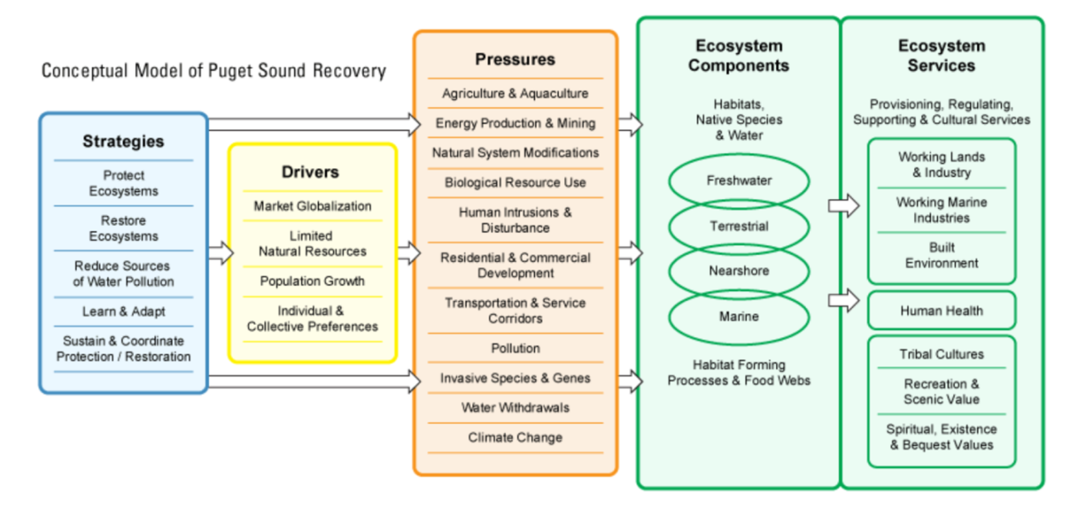

Figure 1. Conceptual model of Puget Sound recovery. From the Puget Sound Partnership Biennial Science Work Plan, 2012.

### Need for a Puget Sound pressures assessment

The design of a pressures assessment approach, or a risk assessment approach more generally, depends primarily on the goals of the management actions being supported (Suter, 2007). In other words, risk assessment is primarily about technical support for decision-making under uncertainty. Implementation of the pressures assessment methodology laid out in this technical memorandum should support a broad array of Puget Sound recovery decision and planning activities including:

* Evaluating barriers to ecosystem recovery;
* Coordinating future iterations of watershed-scale planning, including prioritizing near-term recovery actions;
* Providing a common framework and foundation for more detailed local-scale pressures/risk assessment efforts;
* Prioritizing recovery strategies and sub-strategies in the PSP’s recovery plan, the Action Agenda, and otherwise informing future updates to the Action Agenda;
* Prioritizing monitoring gaps by the Puget Sound Ecosystem Monitoring Program (PSEMP);
* Supporting the implementation of the PSP’s Adaptive Management Framework;
* Informing updates to PSP’s system of indicators and targets;
* Identifying information and knowledge gaps and prioritizing research needs related to pressures, stressors, and impacts to Puget Sound ecosystems, ecosystem components, and human wellbeing; and
* Supporting communications about the importance of pressures, pressure reduction strategies, and related issues between partners, decision-makers, stakeholders, and the public.

### Goals of Puget Sound pressures assessment

The proposed pressures assessment approach is designed to meet all of the criteria required for a fundamental, baseline sound-wide pressures assessment:

1. Comprehensive consideration of all of the known stressors associated with significant pressure classes, based on an accepted taxonomy of pressures and stressors;
2. Assessment and evaluation of pressures at appropriate spatial and temporal scales;
3. Use of a transparent, repeatable, and updatable approach for assessment that includes:
   1. Robust conceptual models of ecosystem vulnerability and/or resilience to pressures;
   2. Robust quantitative evaluation system that supports comparisons, based on the conceptual models;
   3. Appropriate assessment endpoints that meet the requirements and expectations of decision-makers, planners, stakeholders, and scientists (Section 3, “Assessment Endpoints”);
4. Assessing, representing, propagating, and interpreting uncertainty within the assessment;
5. Expert workshops and synthesis of gathered information, with the opportunity for iterative refinement of models, information, and uncertainty assessments, based on expert inputs.

Each of these aspects of ecosystem pressures assessment is described in detail in Section 3, “Proposed pressures assessment approach”. There are a number of guides to conducting ecological risk assessment and ecosystem pressures assessments, which the above criteria synthesize and incorporate (e.g., Landis and Wiegers, 1997; EPA, 1998; Moore, 2001; Suter, 2007; Menzie et al., 2007).

When implemented, the Puget Sound pressures assessment should support the comparison and ranking of ecosystem stressors across assessment endpoints, within and across individual watersheds and marine sub-basins, and at the scale of Puget Sound. As described in other applications of the “vulnerability of marine ecosystems” approach (Halpern et al. , 2007; HELCOM, 2010; Halpern et al., 2008; Teck et al., 2010), procedures can be defined for summing scores over stressors, over endpoints, and over assessment units (e.g., individual watersheds or sub-basins), to yield various comparisons between stressors, potentially at multiple scales. Mapping potential impacts will require additional work beyond the assessment of intrinsic ecosystem vulnerability, as described later in this section.

### Concepts and framework

To place this Puget Sound pressures assessment in the more general context of risk assessment, we introduce several important concepts and provide a conceptual model to illustrate the pressures assessment framework. In its broadest sense, cutting across the many activities that fall under the name, risk assessment refers to “technical support for decision-making under uncertainty” (Suter, 2007). Typically “risk” is defined to include a notion of the probability of one or more (usually) undesirable event(s) and a measure of the consequences or losses associated with the event(s) (Table 1). Within that basic framework, risk assessment can address a range of topics from public health and safety considerations to investment portfolios. Before introducing the regional pressures assessment framework, we begin with the environmental risk assessment framework put forth by the US Environmental Protection Agency (USEPA), with a focus on toxicity to humans or other biological endpoints associated with exposure to various chemicals (Figure 2). In chemical risk assessments, the focus is on estimating the magnitude and timing of exposures associated with various pathways and the intrinsic biological effects (sensitivity) associated with exposure to the chemical in question. Biological effects typically may include mortality, chronic physiological impacts, and reproductive aberrations or abnormalities. Such risk assessments typically consider single chemicals or chemical classes associated with human activities, e.g., pesticides, herbicides, organic solvents, metals, polychlorinated biphenyls, or dioxins. Most often such risk assessments deal with only one or a few biological endpoints, e.g., toxicological responses in human beings or other species to dioxins.

Table 1. Typical definitions of relevant concepts (Suter et al., 2007; De Lange et al. 2010).

|  |  |
| --- | --- |
| **Term** | **Definition within this assessment method** |
| Exposure | Contact of an organism with a chemical, radiological, or physical agent. Exposure is quantified as the amount of the agent available at the exchange boundaries of the organism (e.g.; skin, lungs, gut) and available for absorption. Effects to organisms can be direct (toxicity) or indirect (habitat changes). |
| Hazard | A threatening event, or a *potentially* damaging phenomenon, within a given time period and area. |
| Risk | Expected losses due to the potential (uncertain) occurrence of a particular hazard for a given area and reference period. Based on mathematical calculations, risk is the interaction of the probability of a hazard occurring and the vulnerability, which may also be uncertain. |
| Vulnerability | The degree to which a system is susceptible to, and unable to accommodate disturbance or other forms of change. |
| Ecosystem vulnerability | The potential of an ecosystem to modulate its response to stressors over time and space, where that potential is determined by ecosystem characteristics that may include many levels of organization. A high vulnerability reflects the relative inability of the ecosystem to tolerate stressors over time and space. Ecosystem responses may include a combination of species, community, and habitat-related changes. |
| Ecosystem resilience | Ecosystem resilience can be defined as a measure of the magnitude of disturbance that can be absorbed before the ecosystem changes its regime by changing the state variables and processes that control behavioral ranges and dynamics. |

For site-specific ecological risk assessments, a characterization of the threatened biological community (e.g., structure, function, sensitivity, vulnerability, and economic value) is required. Site-specific ecological risk assessments may include probabilistic methods in which the likelihood of exposure and effects are considered, combined with other lines of evidence such as knowledge about the ecological functions of sensitive or keystone species (De Lange, 2010). The description of the biological systems at risk, beyond a simple notion of “potential individual response”, becomes a relevant component of the characterization and quantification of ecological risk (Figure 3). This shifts the risk assessment focus from laboratory toxicological studies of effects on individual organisms (Figure 2) to field-scale studies of effects at the population, community or ecosystem level (Figure 3).

measured

sensitivity

measured

exposure

Figure 2. Traditional Risk Assessment Components (Landis and Wiegers, 1997)

Figure 3. Regional Pressures Assessment Framework

assessed, modeled

stressor intensity

intrinsic vulnerability

assessed, modeled

The move from individual risk to ecological risk requires a change in thinking, from sensitivity at the individual organism level to vulnerability at higher organization levels (Suter, 2007). There is a significant literature exploring the theoretical foundations of the extrapolation from individual to ecosystem effects within the ecological risk assessment paradigm (e.g., Hunsaker et al., 1990; Landis and Wiegers, 1997; Suter et al., 2005; Suter, 2007, and references cited within; De Lange, 2010). Within the ecological risk assessment framework and within the concept of ecological vulnerability in particular, capturing the essential biological and ecological characteristics of the ecosystem or ecosystem components at risk is considered an integral step. De Lange et al. (2010) describe different vulnerability analysis methods developed for single-species populations, communities (populations of multiple species) and ecosystems (both communities and habitats), as well as examples of methods developed for socio-ecological systems. As De Lange et al. (2010) notes, all of these methods tend to share certain defining aspects, including the use of expert judgment, stakeholder consultations or other inputs, pressure/threat rankings and mappings, and results of a necessarily relative nature. We discuss these issues further in the “ecological vulnerability approaches” part of Section 2. The essential connection to make is that, within the pressures assessment methodology, the intrinsic ecosystem vulnerability concept is analogous to “sensitivity” and the stressor intensity/endpoint joint assessment is analogous to “exposure” (Figure 2, Figure 3). Note that the structure of Figure 3 was chosen to highlight the analogies between the terminology used in traditional risk assessment and the pressures assessment framework. When modeling ecosystem impacts using intrinsic vulnerability, stressor intensity, and endpoints, a somewhat different model structure is used (cf. Figure 5).

#### Pressures taxonomy developed by the Puget Sound Partnership (PSP)

In recent years, the Puget Sound Partnership has drafted a taxonomy of the pressures considered to be those most directly influencing Puget Sound ecosystems and human wellbeing (Stiles et al., 2013). Most of the pressures in the PSP taxonomy represent sources of stress (for example, land development or marine shoreline modifications) that act on ecosystems via one or more stressors (e.g. habitat conversion or barriers to sediment delivery). In a few cases, the pressure class is synonymous to a stressor (e.g., derelict fishing gear). The elements of the pressure taxonomy - sources, stressors, mechanisms and the resulting ecological impacts, or stresses – are defined briefly here, but the reader is directed to the pressures taxonomy documentation for detailed information (Stiles et al., 2013). Specific examples of relevant pressure classes and stressors that will be considered in the proposed assessment are provided in Section 3.

Pressures act on Puget Sound ecosystem components via one or more associated stressors. Within the PSP pressures taxonomy terminology, stressors can also be thought of as the most proximal causes of ecosystem change. For example, specific structural changes[[4]](#footnote-4), contaminant flows, and other process modifications and human activities that directly impact habitats, species and people.

Stressors act on species, habitats and ecological processes via primary mechanisms of action: 1) direct reduction of species fecundity or survival, 2) habitat destruction, or 3) habitat degradation and fragmentation (Balmford et al 2008). We note that these primary mechanisms encompass a broad range of biophysical, chemical, and hydrological structural and process-related changes. Mechanisms of action can also be thought of as descriptors of the relationship between a stressor and an ecosystem component or attribute of interest. “Stresses” refers to the ecological effects, or ultimate impacts, of a stressor on an ecosystem or species, following the terminology of Stiles et al. (2013).

We note that human activities that are classified as “pressures” may also contribute positively to human wellbeing (Schneidler and Plummer, 2009; Figure 4). A common example of a pressure is shoreline hardening, which has negative physical and biological impacts related to the loss of sediment supply to beaches, potentially impacting nearshore habitat formation and maintenance (Shipman et al., 2010). However, shoreline hardening (armoring) also may be perceived as being beneficial to human wellbeing, since personal property may be protected.

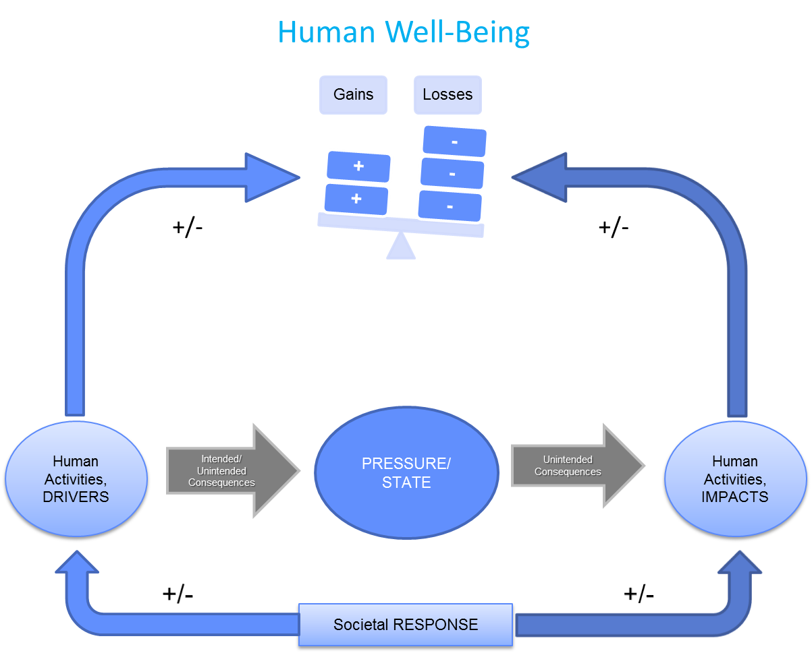

Figure 4. Human activities as pressures and as drivers of human wellbeing (adapted from Schneidler and Plummer, 2009).

### 

### Mapping pressures, stressors, and impacts

The pressures assessment distinguishes between intrinsic ecosystem vulnerability, stressor intensity and (spatial) distribution, and assessment endpoint distribution, three distinct aspects of relating pressures and stressors to ecosystem impacts. This distinction is based on a simple conceptual model that underlies the Vulnerability of Marine Ecosystems (VME) approach to mapping marine pressures and potential impacts (adapted from Halpern et al, 2008 and HELCOM, 2010):

$I_{c}=\frac{1}{m}\sum_{i=1}^{n}{\sum_{j=1}^{m}{P_{i} ∙ E_{j} ∙ μ_{i,j}}}$, where

* + Pi is the normalized value of the intensity of a pressure “i” at the spatially-referenced cell of interest (c);
  + Ej is the presence (1) or absence (0) of endpoint type “j” for the cell;
  + μi, j is the model-calculated vulnerability constant that transforms the pressure intensity (Pi value) into a measure or index of the expected impact for a present endpoint (Ej=1);
  + n is the total number of pressures and m is the total number of endpoint types.

The mapping procedure implied by this equation uses three fundamental types of information: (1) mapped pressure data interpolated over grid cells, (2) a score-based assessed vulnerability factor (μi, j) to transform a pressure intensity (Pi) to a potential impact for the endpoint (Ej), and (3) information on the presence or absence of ecosystem endpoints in a grid cell. As written, the equation calculates the cumulative impact, i.e., the summation over all pressures that act on the endpoint present at the cell. Using variations on this equation, the potential impacts and pressures can be modeled and mapped in a number of ways, depending on the focus of interest. For example, potential impacts for individual pressures/stressors can be mapped for comparison between endpoint types, among other potential queries. The VME approach focuses only on spatially-explicit assessment endpoints, which reflects the focus on habitat types. Relevant examples of the application of this approach include pressure and impact indices mapping for the Baltic Sea (HELCOM, 2010) and threats and impacts mapping of global marine ecosystems (Halpern et al., 2008), the California Current (Halpern et al., 2009), Canadian coastal Pacific waters (Ban et al., 2010), and Massachusetts state waters (Kappel et al, 2012).

In terms of the proposed pressures assessment framework for Puget Sound, the conceptual model underlying this equation can be summarized as (Figure 5):

Figure 5. Potential ecosystem impacts as a function of intrinsic vulnerability, stressor intensity and distribution, and endpoint distribution.

Note the correspondence between ecosystem impact, intrinsic vulnerability, stressor intensity/distribution, and endpoint distribution with terms Ic, **μ**i,j, Pi, and Ej in the potential impacts equation from the VME approach. The significant differences between the VME approach to mapping potential impacts and the approach proposed here are the scale of application, the treatment of the spatial distributions of stressor intensities and endpoints, and the use of species for some assessment endpoints. In the VME approach applied to the Baltic Sea (HELCOM, 2010), potential impacts are calculated for (uniformly sized) grid cells treating stressor intensity as a normalized index estimated from summarized data interpolated across cells and endpoints are accounted for using a presence/absence index. In our approach, we similarly define stressor intensity using states that reflect historically observed and anticipated future values and use spatial analysis of available data to estimate stressor distribution, using data sets and expertise at the assessment unit scale (Section 3). Similarly, we use spatial analysis of endpoint distribution to define where ecosystem impacts would be possible for the assessment endpoint in question. Section 3 provides a more detailed discussion of the meaning and interpretation of intrinsic vulnerability, stressors, and endpoints, including a discussion of the treatment of uncertainty in the information underlying the assessment.

### Probabilistic modeling of assessment uncertainty

Risk assessments, of which ecosystem pressures assessment is a particular kind, inherently involve uncertainty. There are, of course, many sources of uncertainty in the consideration of the potential impacts of pressures on different aspects of an ecosystem, which could be organized in a number of ways. In assessing and representing uncertainty, we use the decision analytical approach to interpreting and modeling uncertainty as Bayesian probability (Howard, 1968; Howard, 1988; Clemen, 1996; Jaynes, 2003). In Section 3, the treatment of uncertainty using probabilistic definitions of assessment variables is discussed specifically. Here, we introduce a few concepts that Section 3 will build on.

#### Sources of uncertainty

Uncertainty is, of course, pervasive in ecological management and recovery planning (Maier et al., 2008). There are multiple possible taxonomies of uncertainty relevant to scientific information and environmental decision support with a large multidisciplinary literature to choose from. The taxonomy proposed by Regan et al. (2002) is adopted here because of its useful distinction between epistemic uncertainty, which refers to our uncertainty in the knowledge and information associated with the states and behaviors of systems, and linguistic uncertainty, which refers to our uncertainty arising from the ambiguity, vagueness, and context dependence inherent in natural language. In expert elicitation within complex endeavors like ecosystem pressures assessment, we seek to minimize the linguistic uncertainty (error) introduced due to different experts assuming different contexts, ambiguous or vague terminology, and other sources of indeterminacy and under-specificity. The admittedly ambitious goal is for the uncertainty expressed by experts to reflect epistemic uncertainty due incomplete knowledge, lack of data, natural (irreducible) variation, and other non-linguistic sources of uncertainty.

#### Reducing biases in uncertainty elicitations

In a set of landmark studies, Amos Tversky and Daniel Kahneman documented that people use a limited number of imperfect heuristics to reduce the cognitive complexities involved in probabilistic reasoning to simpler operations. Such heuristics are quite useful in sense that they allow people to make quick determinations about complex information, but they lead to predictable (and sometimes severely flawed) biases (Tversky and Kahneman, 1974). Formal studies of the issue of the “predictable biases” involved in judgment under uncertainty have resulted in various approaches being developed to deal with them, including visual aids, lottery/betting frameworks, scoring rules, etc. The use of demonstrated techniques (Morgan and Henrion, 1990) for reducing biases and fostering useful discussions of uncertainty between experts will be an important part of the model elicitation workshops, as described in the last section.

#### Unfamiliarity with Bayesian probability models of uncertainty

Since many natural scientists are not well acquainted with the use of Bayesian (subjective) probability or the use of conditional probability to describe uncertainty, various approaches have been developed to facilitate the elicitation process, dealing with the problems of ease-of-use and well-documented biases. Studies demonstrate that the use of probabilities, odds, log-odds, ranges, etc. in probabilistic assessments converge when administered well, with a widely accepted conclusion that choosing an approach that matches the cognitive style, technical background, and preferences of the experts involved is the more important consideration (Morgan and Henrion, 1990).

## 2. Pressures assessment approaches considered

In this section, we briefly describe three broad approaches to conducting a comprehensive regional ecosystem pressures assessment: 1) ecological vulnerability assessment; 2) DPSIR models; and 3) ecological risk assessment. The need for comprehensive assessments of the many anthropogenic pressures impacting coastal ecosystems has been broadly recognized (MEA, 2005, Crain et al. 2009). Given the large number of combinations of pressures and assessment endpoints and the scales of interest for any given regional or larger assessment, the paucity of appropriate data to support analytical approaches to meet this need is also broadly recognized, and holds true in Puget Sound (PSAT, 2005; Halpern et al., 2009; Crain et al., 2009; De Lange et al., 2010; PSP, 2010; HELCOM, 2010; Kappel et al., 2012; PSP, 2012). For our purposes, a comprehensive consideration of all relevant stressor/endpoint combinations is necessary, and only an expert elicitation-based[[5]](#footnote-5) approach to intrinsic vulnerability assessment supports this need for comprehensiveness at present. While any of the three approaches described could, in theory, be performed using expert elicitation, the ecological vulnerability assessment approach has several significant applications at regional and larger scales (*ibid.*). Our goal is to develop a foundational baseline assessment that can be refined and improved upon in the future, as data is collected, synthetic models are developed and improved, and new information is developed and interpreted.

### Ecological vulnerability approaches

From the perspective of ecological vulnerability approaches, how a stressor affects a particular ecosystem component (i.e., assessment component) depends in large part on its *vulnerability*. In typical definitions, vulnerability is determined by 1) *exposure*, which represents the expected degree to which an ecosystem component may experience a given stressor when typically exposed; 2) *sensitivity*, which represents the expected degree to which a community or other ecosystem component would be affected by the stressor; and 3) *resilience*, which represents the ability of the affected assessment endpoint to recover from disturbance caused by the stressor (Turner et al., 2003; De Lange et al., 2010; Kappel et al., 2012). As described in Section 1, “Mapping pressures and impacts”, a spatially-explicit characterization of expected ecosystem impacts involves consideration of the ecological vulnerability of an assessment endpoint for a given stressor, as well as information on the magnitude and spatial and temporal distribution of the pressure intensity (or similar measure) and the spatial distribution of the assessment endpoint.

Williams and Kapustka (2000) define ecological vulnerability as “potential of an ecosystem to modulate its response to stressors over time and space, where that potential is determined by characteristics of an ecosystem that include many levels of organization. It is an estimate of the inability of an ecosystem to tolerate stressors over time and space.” The concept of ecological vulnerability can be applied at several hierarchical levels, ranging across the levels of organisms, populations, communities, ecosystems, and land- and seascapes (Suter et al., 2005; De Lange et al., 2010).

The vulnerability of an ecosystem component is, of course, a complex issue that ideally requires significant knowledge about characteristics of the abiotic and biotic system in question, such as (De Lange, 2010):

* Details of exposure, which determine the extent and magnitude of interactions between stressors and assessment endpoints;
* Community structure and functioning, including species composition and other aspects of structural biodiversity, and the major functional features of the community;
* Community sensitivity, as distributed to specific stress factors among the species making up community;
* Ecological role of sensitive species within the community, including keynote species and/or species that structure habitats (“ecosystem engineers”);
* Habitat vulnerability, described as potential habitat changes due to interacting stressors, linking the community level to the ecosystem level; and
* Ability of an ecosystem component to recover from or adapt to stressors/changes

Other ecosystem characteristics are relevant, which should be considered within the context and documented within the background assumptions behind the assessment. These include the current and potential state of ecosystem components as distributed within the geographic area being assessed, which could be referred to as “reference conditions”. Other context, such as the values placed on the ecosystem component by people or the role of the component within its larger ecosystem are reflected in the choice of assessment endpoints, with the rationale for these choices being documented within the assessment.

#### Vulnerability of Marine Ecosystems (VME) framework

In the context of marine ecosystems, Halpern et al. (2007) developed the vulnerability of marine ecosystems (VME) framework to elicit expertise about ecosystem vulnerability to human stressors, accounting for ecological context and acknowledging that the same activity may have different effects in different ecosystems (Teck et al. 2010; HELCOM, 2010). The framework has been applied at scales ranging from global (Halpern et al., 2008) to regional (Halpern et al., 2009; Teck et al., 2010; Kappel et al., 2012), including scales directly relevant to the Puget Sound (HELCOM, 2010; Ban et al., 2010).

Building on the ecosystem vulnerability review and framework developed by Wilson et al. (2005), the “vulnerability of marine ecosystems” model (Halpern et al., 2007) was designed to address several related questions:

1. What are the most important pressures within and across assessment endpoints?
2. Which assessment endpoints are most vulnerable to pressures?
3. Which factors drive differences in ecosystem vulnerability, and is it possible to quantify those differences?

The VME considers the spatial scale, frequency of occurrence/exposure, and the nature of potential impact for each combination of stressor and assessment endpoint (marine ecosystem types, in their assessment); the resistance of the assessment endpoint to disturbance posed by each pressure; and the expected recovery time (i.e., resilience) of the assessment endpoint following the cessation of disturbance. Since we use a broader suite of types of assessment endpoints (including those related to human wellbeing) and include terrestrial and freshwater aquatic ecosystem assessment endpoints, we propose to modify the ecosystem vulnerability criteria somewhat from the definitions used by Halpern et al. (2007), as explained in Section 3.

Halpern et al. (2007) discusses how several VME model results compared to direct expert opinion about the relative importance of pressures within the marine ecosystem types used as assessment endpoints. While the vulnerability model results are themselves based on expert elicitation, the use of a model and comparable vulnerability factors to decompose the question of relative importance of pressures appears to result in more robust comparisons of pressures/threats across pressures and threats. One possible explanation is that linguistic uncertainty is higher when the question of relative importance is posed directly (in the absence of a model), since, for example, thoughts about existing pressure intensity levels within the region of interest could bias thoughts about the intrinsic vulnerability of an endpoint for a given pressure.

Before we describe the proposed Puget Sound pressures assessment approach in Section 3, in the remainder of this section, we describe other possible approaches, each of which have their own pros and cons relative to the VME approach, but none of which surpass the VME in meeting the goals of this assessment, as previously described.

### DPSIR models

An organizing framework for dynamic coupled human-natural system analyses is the ‘Driver-Pressure-State-Impact-Response’ (DPSIR) conceptual modeling approach (EEA 2007, CEROI 2008).  The DPSIR approach allows development of a rationale or narrative for why a particular threat/driver is of concern.  Conceptual models such as DPSIR are useful for organizing the state of scientific information demonstrating cause-and-effect linkages between ultimate drivers of ecosystem change, and likely ecosystem responses to natural or human-induced changes in those drivers (EEA 2007).  The DPSIR framework can also be used to highlight important ecosystem attributes and develop hypotheses about how the system works. Management strategies can be developed based on the spatial distribution of threats from drivers and pressures, information on thresholds linking the magnitude of the threats to likely changes in ecosystem attributes, and adaptive feedback of the response actions (Figure 6, Ruckelshaus et al. 2008). To better identify indicators of ecosystem health, Puget Sound-specific DPISR models have been developed for climate change, residential, commercial and industrial development, shoreline modification, pollution, and the introduction of invasive species (Pearson et al. 2009). The DPSIR framework "(1) identifies likely causal linkages between human activities and changes in ecosystem states; (2) simplifies the complex relationship between human activities and changes in the environment; (3) is a tool for communicating complex relationships and potential solutions between policy makers, scientists and the general public; (4) provides a framework for identifying indicators and what they indicate (e.g. indicators of pressures and states); (5) allows for a better understanding of the likely effects of response actions on the desired state; and (6) is widely used in the peer–reviewed literature" (Pearson et al. 2009).

We propose the use of DPSIR models, or other conceptual causal models, within the proposed pressures assessment approach as a means of communicating between experts and assessors in discussions of assumptions for given stressor/endpoint pairs. These discussions would likely include thoughts about stressor and endpoint definitions, spatial and temporal assumptions, vulnerability model definitions, and so forth.

We will now describe several ecological risk assessment approaches that have been previously applied in Puget Sound.



Figure 6. Conceptual DPSIR model linking drivers and pressures to the ecosystem state, impacts to ecosystem components, and adaptive feedback for response actions (Ruckelshaus et al. 2008).

### Ecological risk assessment applied to Puget Sound

There are three types of ecological risk assessments that have been conducted within Puget Sound. The first type is the risk assessments associated with decision-making involving sites managed under the Comprehensive Environmental Response, Compensation and Liability Act (CERCLA), also known as superfund. The second type of assessment is comprised of those done to examine fisheries and marine management issues as part of the National Oceanographic and Atmospheric (NOAA) programs. The third and final type involves the applications of a regional risk model (RRM), in order to examine the risks associated with development of the Cherry Point area. The Cherry Point approach has become a model system for the development of ecological risk assessment. This brief summary provides an overview of the assessments in each of these categories.

#### Risk assessment for sites managed under CERCLA

The Commencement Bay site was a case study used for the development of current USEPA guidance (USEPA 1993). The Lower Duwamish Waterway (LDW) contaminated site evaluation is more recent and will be used as the example in this review. The LDW risk assessment was performed in the mid-2000s (Windward 2007) and is typical of current practice under CERCLA.

The LDW risk assessment incorporates the USEPA guidance for ecological risk assessments (USEPA 1998) and follows the USEPA framework (USEPA 1992). These risk assessments follow the structure of a problem formulation, effect analysis, exposure analysis, risk calculation and characterization. Emphasis is placed on calculating chemical exposures to specified endpoints, typically species. A threshold response value is calculated for each endpoint based upon available toxicity data usually reported as a no-effect or low-effect concentration or dose. The threshold response value is divided into the expected concentration resulting in a ratio called the hazard quotient. A ratio greater than 1 is assumed to have a risk that may be unacceptable and a ratio lower than one is considered to be acceptable.

In the LDW metals and persistent organic pollutants (PCBs and DDT and its degradation product) were the focus of the risk estimation. Since CERCLA specifically deals with chemical contamination this focus is typical.

Uncertainty in the analysis was extensively described but not analyzed in a probabilistic fashion. Monte Carlo and other probabilistic simulation techniques that can explicitly combine distributions generated for exposure concentrations or effects levels can be used. The LDW assessment did not use a probabilistic approach to describe uncertainty, as was typical in the CERCLA driven ecological risk assessments in the mid-2000s.

#### Fisheries and marine resources management

Samhouri and Levin (2012) presented a risk analysis derived from the conservation biology tradition and not that of USEPA, which was focused on chemical contamination. They used a ranking methodology derived from Burgman (2005), which is similar to that of Halpern (Halpern et al 2007, 2008).

The goals of the assessment of Samhouri and Levin are focused on community and ecosystem attributes such as species diversity. Exposure to contaminants was one consideration but a number of other characteristics were included in the assessment. Indicator species were selected that had an assumed link to food web attributes such as ecosystem wide consumption, primary production. Resilience was measured by the ecosystem reorganization index.

Uncertainty was not addressed probabilistically but by a ranking of data quality. While data quality is one aspect of uncertainty, uncertainty in the nature of cause-and-effect responses, model uncertainty, linguistic uncertainty, and so on were not addressed.

Examples of findings were that Chinook salmon and Pacific herring are at greater risk from a number of human activities within the study area than other assessment endpoints. This did vary depending upon the kind of stressors involved.

One of the strengths of the Samhouri and Levin approach is that it was spatially explicit and estimated risk to the various management areas as delineated by the Puget Sound Partnership. Gradients of risk to Chinook salmon and Pacific herring are clearly observed in the risk estimates from coastal development and industry land uses.

Although not touted as a risk assessment, Feist et al’s (2011) study exploring the risk factors contributing to prespawn mortality (PSM) in Coho salmon within part of Puget Sound has some of the elements of a risk analysis. They assumed a cause-effect relationship between contaminants in watersheds and PSM for a variety of land uses and used a model to examine the relationships between the geospatial features and the occurrence of PSM. The model results were used to calculate areas where PSM would likely occur and could be used to characterize the associated uncertainty. While the authors do not call their study a risk assessment, the forecast mortality under different development scenarios, so this study clearly has some of the classic characteristics of a risk assessment approach.

#### Use of the relative risk model for regional risk assessment

The relative risk model (RRM) for regional risk assessment was developed in the late 1990s for use at regional scales (Landis and Weigers 1997). The RRM uses ranks to combine multiple sources with multiple stressors to expose multiple habitats as a way of estimating impacts. A number of other research groups have used the RRM to estimate toxicity in a variety of scenarios around the world (Landis 2007). In the initial versions of the RRM uncertainty was documented and later Monte Carlo analysis was used to estimate uncertainty in the scores and final rankings. In more recent applications, Bayesian networks have been used to describe causal relationships and to incorporate uncertainty.

The initial use of the RRM in Puget Sound was to estimate risk factors contributing to the decline of the Pacific herring at Cherry Point, near Ferndale (Landis et al 2004, 2005). This assessment demonstrated that although some activities at Cherry Point posed a risk, the majority of the risk was from sources outside of the region. Hayes et al (2004) looked at a number of endpoints other than Pacific herring in the same area including birds, fish and invertebrates. Nonpoint sources were major contributors to risk.

The RRM was also used to estimate risk due to nonindigenous species (NIS). Colnar and Landis (2007) examined the risk due to the invasion of the European Green crab into the Cherry Point region. The relative risk scores were calculated for la Nina and el Nino years. European Green crab did pose a risk in the Cherry Point region to a number of endpoints. Similarly Seebach et al (2010) examined the risks due to the establishment of Sargassum within the Cherry Point area. In this instance declines in some species were considered likely but to other endpoints, Sargassum would be beneficial because it serves as new habitat.

Hines (2013) used a Bayesian network-based RRM to estimate risk to Coho Salmon in the Puyallup River basin and Tacoma. Risk increased as the areas near the Port and City of Tacoma become more urbanized. The uncertainties were clearly expressed in the distributions in the nodes of the Bayesian network and the driving factors were listed in the sensitivity analysis. The study also incorporated the implementation of low impact development (LID) as a management tool for reducing risk. The findings suggest that a great deal of LID would be required in the most urban regions to reduce risk.

## 3. Proposed pressures assessment approach

The proposed pressures assessment framework provides a methodology for evaluating, comparing, and ranking the potential impact of stressors on important assessment endpoints, where the assessment endpoints are chosen to reflect the recovery and management concerns of the Puget Sound Partnership and its many partners. The framework is designed to 1) assess scales of impacts ranging from localized single species to the ecosystems that make up Puget Sound; 2) span the full suite of stressors and ecosystem endpoints necessary to evaluate and rank stressors across Puget Sound; 3) assess and incorporate uncertainty in expert elicited information; and 4) use expert judgment within a transparent process that would support reproducibility and future updates. The assessment approach builds on the “vulnerability of marine ecosystems” (VME) approach developed by Halpern et al. (2007), which has been applied at scales ranging from global marine ecosystems to regional coastal waters. We depart from the VME approach in a number of ways, including our inclusion of terrestrial and freshwater aquatic ecosystem assessment endpoints in addition to marine and nearshore endpoints. We also extend beyond the VME’s exclusive use of habitat-type endpoints to include habitat-types, species, communities, water quality and quantity, and human wellbeing endpoints, reflecting the Puget Sound Partnership’s recovery goals. In addition, we propose a different approach to assessing and incorporating uncertainty and aggregating the vulnerability criteria into a vulnerability score for a given stressor/endpoint pair. Each of these modifications is detailed below.

### Intrinsic vulnerability score (μ)

The concept of comparing the degree of threat or potential for change between different pressures and stressors is well accepted in the scientific community, across different disciplines, including both social and natural sciences (Williams and Kapusta, 2000; Turner et al., 2003; Adger, 2006; De Lange et al., 2010). Models of ecological vulnerability typically include various aspects reflecting “exposure” to the stressor, “sensitivity” of the affected endpoint to the stressor, and “recovery potential” of the endpoint from the stress (Suter, 2007; De Lange 2010), with endpoints ranging from organisms to ecosystems.

The intrinsic vulnerability scores (μijk) are defined over combinations of stressors (i) and assessment endpoints (j) given an assessment context[[6]](#footnote-6) (k). The vulnerability criteria states and associated criteria scores and the approach used to aggregate them into an intrinsic vulnerability score are described in detail below. The μ score reflects the impact that a given stressor would potentially exhibit on the assessment endpoint. It is important to keep in mind that μijk is a model-defined constant (score) aggregated from expert-assessed vulnerability criteria scores, and is defined at a particular assessment scale.

### The ecosystem vulnerability model that defines μ

The ecosystem vulnerability model (Figure 7) consists of several parts: 1) criteria that together define vulnerability for a particular stressor/endpoint pair, 2) a scoring system for each of the vulnerability criteria, 3) a probabilistic structure for incorporating uncertainty, and 4) an aggregation model that combines the vulnerability criteria scores into an intrinsic vulnerability score, μijk, for stressor “i” and assessment endpoint “j”. Each of these parts is described below.

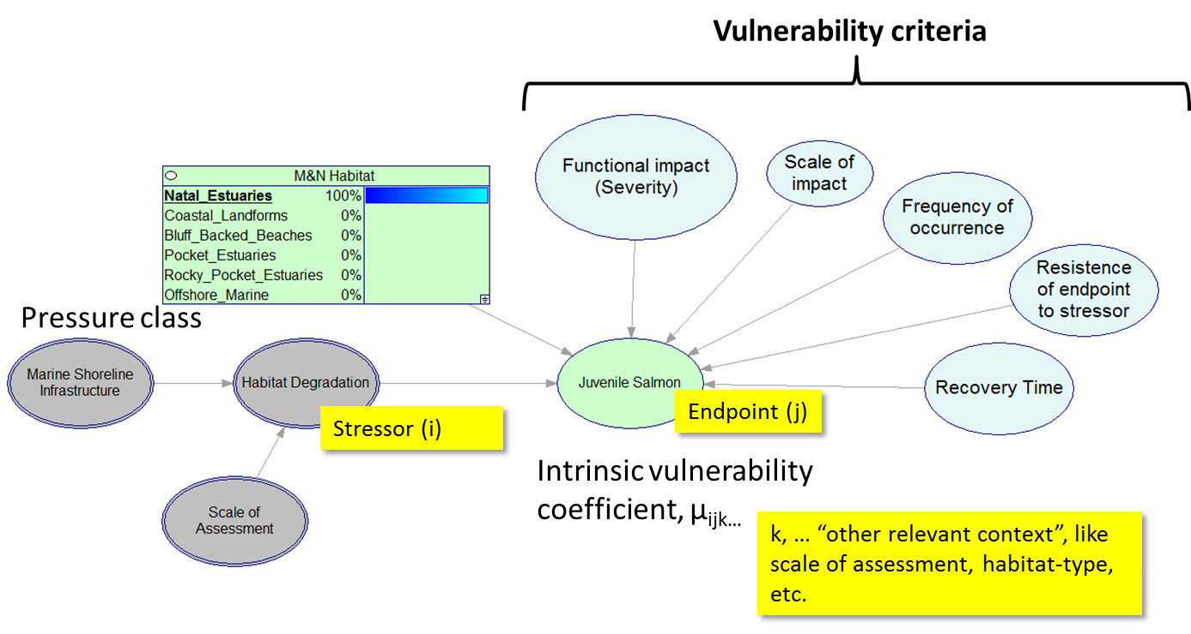

Figure 7. Ecosystem vulnerability model as a Bayesian network.

#### Vulnerability criteria

The vulnerability criteria are each defined over states ranging from a negligible outcome to a catastrophic outcome assuming that the endpoint in question is exposed to a “high level” of the stressor, with interpretations of states being particular to each criterion. None of the stressor/endpoint pairs considered would be scored with certainty as having a negligible outcome for the aggregated vulnerability criteria, since this would indicate that the endpoint is not impacted by high exposures to the stressor, in which case the pair would be irrelevant to the assessment. The rationale for including the “negligible outcome” state is to define the baseline of the relative scoring system for assessing potential impacts. Each of the vulnerability criteria is now defined. It should be noted that these definitions are subject to refinement during expert workshops, to reduce ambiguity (or more precisely, “linguistic uncertainty”) among the experts and to potentially improve the underlying model based on insights from the experts involved.

* Scale of impact

The “scale of impact” vulnerability criterion is defined as the typical scale at which a stressor (associated with a pressure class) affects an assessment endpoint (e.g., an ecosystem component), with scale categories ranging from “no impact” to Puget Sound basin-scale impacts. To reiterate, scale of impact does *not* refer to the scale at which particular pressures or stressors occur (some stressor types with small scales of impact are distributed throughout the entire Puget Sound basin). For example, a stressor like “habitat conversion” associated with the “commercial and residential development” pressure class may impact a particular terrestrial species at a scale of 100s of m2, while habitat conversions associated with commercial and residential development could occur throughout the entire Puget Sound basin. In this example, the scale of impact vulnerability criterion would be 100s of m2, capturing the intrinsic vulnerability of the species to a particular land-use change. The scale of impact from habitat losses around Puget Sound could be captured by mapping spatial distributions of the stressor “habit conversions”. The scale of impact criterion is defined to include both direct and indirect impacts. For example, dredging a channel within the mouth of a delta may directly alter a relatively short stretch of the channel but indirectly affect the entire upstream estuary by altering tidal flow. In this case the scale of impact of the hydromodification stressor acting on an estuary endpoint would encompass the entire estuary.

* Frequency

The “frequency” vulnerability criterion describes how often stressor events or activities occur in a given habitat type or impact a particular species/biotic community (or other component). Categories range from “never occurs” to “persistent”. For those stressors that occur as discrete events, frequency refers to how often new events occur, not the duration of a single event. In the case of habitat type endpoints, some stressors may affect only a few species, whereas others affect entire communities or ecosystems. To capture these differences, we define the “functional impact” vulnerability criterion using a four-category ranking scheme ranging from species to ecosystem-level impacts.

* Functional impact

Functional impact reflects the magnitude of the potential impact that a stressor may have on the assessment endpoint. For endpoints that are habitat-types (ecosystems), functional impact is defined in terms of the level of organization impacted by the stressor, ranging from single species impacts to entire ecosystems. For endpoints that are species, the defined states could range from low abundance/productivity impacts to severe impacts. For other types of endpoints, e.g., working lands, impact states would have to be defined on a case-by-case basis during workshops. One of the challenges of this assessment approach will be defining the functional impact criterion across assessment endpoint types such that comparability is preserved.

* Resistance

Resistance describes the average tendency of a species, trophic level, community, or ecosystem to resist changing its current state in response to a stressor. Because of the inherent complexity in describing resistance across multiple levels of organization from species to habitat types and across a large number of substantially different stressor/endpoint combinations, qualitative ranks are used for this vulnerability criterion. These ranks referred to the resistance of the ecosystem components that react to the stressor (i.e., the functional level identified above).

* Recovery time

Recovery time is the average time required for the affected endpoint to return to its pre-impacted state. Because populations, communities, and ecosystems are dynamic in nature, they need not (and are unlikely to) return to their exact pre-impacted condition to be deemed “recovered” (Beisner et al. 2003). For persistent stressors, we may consider recovery time following removal of the stressor.

Suggested definitions for the vulnerability criteria states are shown in Table 2.

Table 2. Suggested vulnerability criteria states (To be refined in workshops).

|  |  |
| --- | --- |
| Scale of Impact | Species Endpoints |
| No threat | Functional Impact |
| Localized | No threat |
| Sub-watershed/Marine segment | Low abundance/productivity impacts |
| Watershed/marine segment | Medium abundance/productivity impacts |
| Basin | High abundance/productivity impacts |
| Frequency of Stressor Occurrence | Severe abundance/productivity Impacts |
| Never occurs | Habitat Endpoints |
| Rare | Functional Impact (based on VME definitions) |
| Occasional | No threat |
| Periodic/seasonal | Species |
| Persistent | Single trophic level |
| Resistance of Endpoint to Stressor | More than one trophic level |
| No impact | Entire Community |
| High resistance |  |
| Medium resistance |  |
| Low resistance |  |
| Recovery Time of Endpoint |  |
| No impact |  |
| Less than 1 year |  |
| 1 - 10 years |  |
| 10 - 100 years |  |
| Greater than 100 yrs |  |

### Assessing and representing uncertainty

In contrast to the “uncertainty factor” approach used by Halpern et al. (2007) to represent uncertainty in the intrinsic vulnerability score, we recommend assessing the uncertainty in each of the assessed vulnerability criteria using expert-elicited probability distributions. While a substantial discussion of the various probability tools that could be used to assess and model assessment uncertainty is beyond the scope of this report, we will briefly describe a few essential tools and refer the reader to other sources for more information. For our purposes, we assume that our uncertainty pertains to a set of discrete states, one and only one of which will hold true[[7]](#footnote-7). Our uncertainty can then be expressed in terms of a discrete (potentially conditional) probability distribution that could be expressed as a probability tree, assuming three generic possible states in this example:

p1

State 3

p3

p2

State 1

State 2

Our uncertainty could then be expressed in terms of the discrete probability distribution, {p1, p2, p3}, where pi is the probability of state “i”. An equivalent representation would be a probability table, with an assumed discrete probability distribution of {0.2, 0.5, 0.3} in this example:

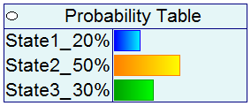

We propose the use of Bayesian networks as a mathematical tool for representing, manipulating, and computing conditional probabilities, enabling the user to reason with uncertain information. There are a number of introductory references that provide detailed background on the theory and use of Bayesian networks, to which we refer the interested reader (Pearl, 1988; Charniak, 1991; Jensen, 1996; Jensen and Nielsen, 2007). In this section, we briefly define them and motivate the proposed usage.

Bayesian networks (or, more generally, probabilistic graphical models) are a hybrid framework which combines uncertainty (probabilities) and logical structure (independence constraints) to compactly represent complex, real-world phenomena. The framework is general in that many of the commonly used statistical models (e.g., Kalman filters, hidden Markov models, regression models) can be represented and computed using graphical models. Probabilistic graphical models have enjoyed a surge of interest in a wide variety of fields in the last three decades, due to the flexibility and power of the representation and advances in the ability to effectively learn model parameters from data and perform inference in ever larger networks, as supported by advances in computing power.

Briefly, Bayesian networks were developed as a general representation scheme for reasoning with uncertain knowledge (Pearl, 1988) and for estimating and modeling uncertain knowledge about future events or complex events that are not observable at an acceptable cost (Jensen and Nielsen, 2007). They organize probabilistic relationships between variables of interest as a graph (or “network”) that represents the conditional dependence between variables. The network is comprised of nodes and arrows (arcs), where the nodes represent the variables of interest and the arcs represent conditional dependence between the connected variables. Although there are several types of variables possible within Bayesian networks, for our purposes, we will focus on “chance variables” (or uncertain variables), represented by ovals in the graphical network (Figure 8). In Figure 8, we show three vulnerability criteria represented as three chance variables (uncertain, unobserved variables), each contributing to a combined over-all vulnerability score. Note that even if we represent the vulnerability score as a deterministic function of the vulnerability criteria (Figure 8), the score is itself uncertain if its inputs are unobserved chance variables (thus retaining their uncertainty). Note that in Bayesian networks, a function can be represented as input variables “pointing to” output variables. Using Figure 8 as an example, if the vulnerability score were treated as a deterministic variable, the graph shown would be equivalent to the equation (assuming a linear-additive function):

$$Vulnerability Score\left(Criterion 1, Criterion 2, Criterion 3\right)=\sum_{i=1}^{l}{p_{i}s_{i}+\sum_{j=1}^{m}{p_{j}s_{j}}+\sum_{k=1}^{n}{p_{k}s_{k}}},$$

where:

* pi is the probability of state “i”;
* si is the model-assigned score for state “i”;
* subscripts “i”, “j”, and “k” are indices over the states of Criterion 1, Criterion 2, and Criterion 3, respectively;
* l, m, and n are the total number of states for Criterion 1, Criterion 2, and Criterion 3, respectively.

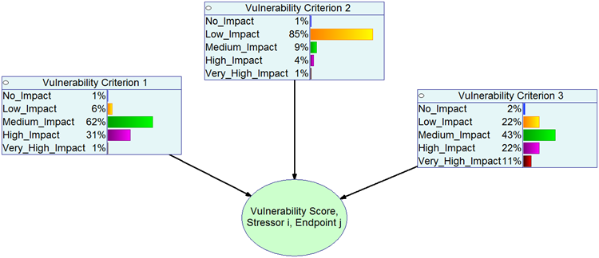

Figure 8. Example of a Bayesian network representation of uncertain vulnerability criteria contributing to an aggregate vulnerability score.

#### Vulnerability criteria as elicited probabilistic variables

Figure 9 shows a more complete example of an ecosystem vulnerability model, again expressed as a Bayesian network. The vulnerability criteria are represented probabilistically by discrete probability distributions that are inputs to a score aggregation model (described in the next sub-section). For this illustration, we will assume an elicitation process with a single expert. The probability distributions reflect the expert’s uncertain knowledge about each of the vulnerability criteria within the context of a given stressor/endpoint pair, for a defined assessment unit of Puget Sound (assessment scales are described later). The context associated with the assessment will be discussed during expert workshops and the documented assumptions will be an important part of the pressures assessment process. As shown in Figure 8, the probabilistic vulnerability criteria are inputs into the expected (computed) intrinsic vulnerability score for the hypothetical endpoint/stressor pair.

The question of how to reconcile different probabilistic assessment responses from different experts for a given vulnerability criterion (for a given endpoint/stressor combination) should be considered carefully (Morgan and Henrion, 1990; Gelman et al., 2003; Burgman, 2005). Halpern et al. (2007) averaged across replicate responses, weighting the responses by the certainty factor elicited from the respondent. We recommend assessment reconciliation using a combination of group deliberative techniques during assessment workshops to facilitate discussion of *why* responses are different, with an opportunity for experts to revise their submitted responses if they desire. Once the refined responses have been collected, they could be combined using a number of techniques, including bootstrapping (simulating) the final “reconciled” assessment distribution from the distributions representing the assessed responses from individual experts.

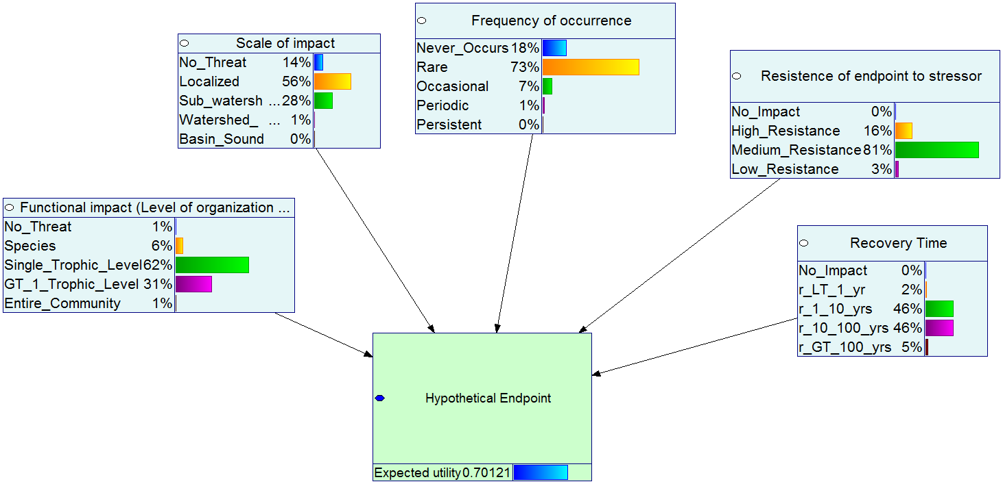

Figure 9. Example of probabilistic calculation of intrinsic vulnerability score from criteria distributions.

While proposing the use of Bayesian networks in the pressures assessment, we make several observations. First, the primary audiences for this description are the assessors and technical staff that will be compiling and using elicited vulnerability criteria responses to generate aggregate vulnerability scores. The domain (subject matter) experts that provide elicited information do not necessarily need to understand the underlying probabilistic tools used within the assessment and there are a variety of ways to communicate about this aspect of the assessment approach. Similarly, assessment results can be communicated in terms of expected vulnerability scores without reference to probability distributions. Note that small Bayesian networks can be easily computed within standard spreadsheet programs and discrete Bayesian networks can be solved using probability trees, with no need for using specialized algorithms. The major point is to use robust methods for assessing, incorporating, and interpreting assessment uncertainty and to introduce the underlying theoretical framework involving Bayesian probability and decision analysis.

### Ecosystem vulnerability score aggregation approach

#### Vulnerability criteria scores from assessed states

Before potential aggregation models are discussed and the process for choosing a single approach is described, we discuss the system used to assign scores to the individual states defined for each vulnerability criterion. In the Halpern (2007) approach, states were ranked and the ranks themselves used as scores within a relative scoring system. This makes the strong assumption that the marginal change in moving from one state to the next is constant throughout the range of states. We propose that within the expert workshop process used to vet and refine the vulnerability model, the marginal change in scores between vulnerability criteria states are explored and chosen, yielding score/state curves of the type shown in Figure 10. The curves may hold generally for stressor/endpoint pairs that apply to an ecosystem domain, or there may be more than one set, each set applying to a particular grouping of stressor/endpoint pairs within an ecosystem domain. The score for a vulnerability criterion would then come from this curve, based on the ranks associated with the probability distribution over the criterion’s states, as elicited during the expert group process.

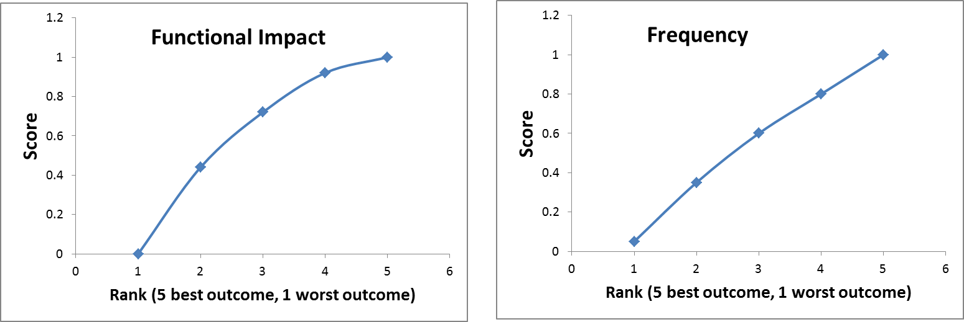

Figure 10. Example of rank/score curves for two vulnerability criteria defined within a single ecosystem domain.

#### Score aggregation model

An important aspect of the ecosystem vulnerability model is the aggregation approach used to combine the vulnerability criteria inputs into a single vulnerability score that represents, in relative terms, how vulnerable an ecosystem component (or assessment endpoint) is to a particular stressor. Halpern et al. (2007) refer to their aggregation approach as a “modifier model”. The Halpern et al. (2007) modifier model that averages across replicate survey (assessment) responses to generate a single (assessed) score for each criterion, which are in turn weighted and summed across criteria to generate a weighted-average vulnerability score using a linear-additive model[[8]](#footnote-8). In the Halpern et al. (2007) approach, the certainty factor is used in the weighting process to inflate the scores of well-documented pressure/endpoint combinations and to depress the scores of poorly-studied combinations. In comparison, a Bayesian probabilistic approach treats uncertainty within a theoretically-robust framework that uses subjective probability to represent and propagate uncertainty. For example, complete ignorance over the states of a vulnerability criterion could be represented as a uniform distribution over the possible states, which would yield a criterion score equal to the average score of the possible states. More precise knowledge could be represented through assigning a higher probability to a particular vulnerability criterion state, which would drive the criterion score toward the score associated with that state, with the exact score depending on the probability distribution that expresses the expert’s uncertainty.

A linear additive aggregation model (Figure 11) is the simplest approach and is based on the strong assumption that the vulnerability criteria are independent of one another in the sense that the contribution to vulnerability from one criterion does not interact with the contribution to vulnerability from another criterion. In the context of Bayesian networks and reasoning under uncertainty, this could be referred to as “causal independence” (e.g., Zhang and Poole, 1996). While this is recognized as a strong assumption the linear-additive model is sometimes justified as a “first order” solution that is supported by a lack of information about interactions.

Linear additive model: U(x1,…,xm) = c1U1(x1) + … + cmUm(xm) , where ci is the weight for the “ith” attribute and Ui(xi) is the utility of attribute xi . A more general model based on multiattribute utility models with interactions is also a possible approach, but requires more attention (Clemen, 1996). With a relatively small number of attribute/state combinations, perhaps the simplest way to think about this approach is to think in terms of scoring exceptions from the score obtained from the linear additive model.

Linear additive model with exceptions: U(x1,…,xm) = c1U1(x1) + … + cmUm(xm) + E1(x1) + … + Em(xm), where Ei(xi) is an exception term (e.g., a penalty) that is non-zero for some states, but zero for most states. For example, if we decide that a score of “0” for vulnerability criteria conceptually related to the sensitivity of an assessment endpoint to a stressor should be penalized beyond the score of “0”, to reflect the severity of the catastrophic outcome, a penalty could be applied for those situations (Table 3). Table 3 shows the situation where a penalty in score is applied since the “Resistance” score is 0 (corresponding to low resistance of the endpoint to the stressor). Of course, Table 3 is a small part of a much larger table (with 5 criteria, each with 5 states, the table would have 3125 combinations), so the number of situations with exceptions could become unwieldy when exceptions are considered on a case-by-case basis. However, if exceptions could be codified using a manageable number of rules, the size of the table is less pertinent.

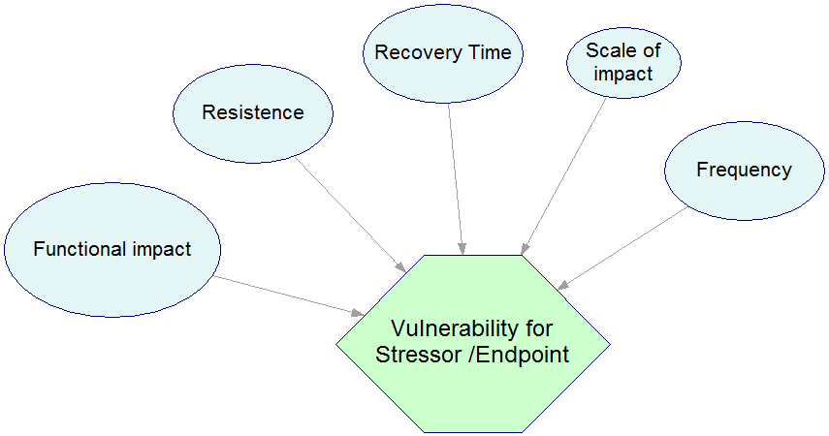

Figure 11. Aggregation scoring function as a Bayesian network value function with vulnerability criteria as chance variable inputs.

Table 3. Use of exceptions to modify linear additive aggregation function.

|  |  |  |  |
| --- | --- | --- | --- |
| STATES→ | No Threat | No Threat | No Threat |
|  | No Threat | No Threat | No Threat |
|  | Never occurs | Never occurs | Never occurs |
|  | Low Resistance | Low Resistance | Low Resistance |
| CRITERIA↓ | No Impact | LT 1 yr | 1 - 10 yrs |
| **Functional Impact** | 1 | 1 | 1 |
| **Scale of Impact** | 1 | 1 | 1 |
| **Frequency** | 1 | 1 | 1 |
| **Resistance** | 0 | 0 | 0 |
| **Recovery Time** | 1 | 0.94 | 0.79 |
| Linear additive score | 0.8 | 0.788 | 0.758 |
| Exceptions | -0.5 | -0.5 | -0.5 |
| Adjusted score | 0.3 | 0.288 | 0.258 |

Another approach is the use of a nested multi-attribute model that decomposes the dimensionality of the score aggregation model into smaller sub-models that become inputs into a new aggregation model. Although the number of variables increases, the size of the new score aggregation table is considerably smaller (Figure 12). In addition to the decrease in the dimensionality of the new aggregation table, the consideration of exceptions becomes simpler. We could define algorithms for identifying exceptions within the “sensitivity” sub-model function (Figure 12), for example, shifting the task to identifying the algorithm rather than searching for exceptions through a large number of possible combinations. For

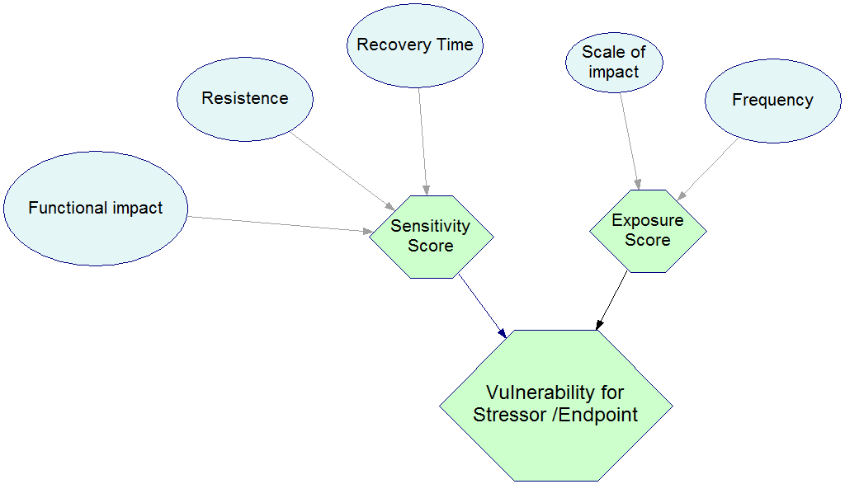

Figure 12. Multiattribute utility model with sub-utility models for “sensitivity” and “exposure”.

example, a multiplicative “sensitivity” sub-model could be defined, which would mean that any occurrence of “0” in any of the vulnerability criteria would generate a “0” in the aggregated sensitivity model score.

The task would be to work with the team of experts charged with refining and vetting the vulnerability model to agree upon an aggregation scoring function that exhibits properties matching our intuitions about exceptions, while remaining simple enough to be tractable and easy to communicate.

### Assessment endpoints

The assessment endpoints for an ecological risk assessment explicitly express the ecological values that are being managed or recovered, often operationally defined in terms of ecosystem components and their attributes (EPA, 1992; Suter, 2007). The choice of assessment endpoints is the process by which ecosystem recovery and management planning goals are translated into specific attributes of the ecosystem that is being recovered and managed. Narrowing down the possible choice of components and attributes into a tractable set is an important part of the process of evaluating and comparing ecosystem pressures, since the chosen set should reflect the biophysical components and processes within the linked natural and human systems being managed, as well as the goals and values of the ecosystem managers. The complexity of this task necessitates the use of conceptual models to ground the choice of assessment endpoints and clear consideration of scale, driving processes, and the different levels of organization that make up the ecosystem (organism, population, community, and ecosystem). For this reason, clear criteria should be used when choosing assessment endpoints (Table 4). Suter (2007) counsels risk assessors to focus on the levels of organization at which the endpoint entities are defined and to look both above and below these levels when considering the meaning of assessment.

Three sets of endpoints will be finalized during initial expert workshops conducted as part of the pressures assessment, each set corresponding to one of the three ecosystem domains within the Puget Sound Partnership’s conceptual model of Puget Sound ecosystem recovery: marine & nearshore, terrestrial, and freshwater aquatic. This technical memorandum offers draft lists of assessment endpoints for each of the domains, for refinement during expert workshops (Table 5.)

Table 4. Criteria for selection of assessment endpoints (Based Box 16.2 from Suter et al., 2007, p. 164)

|  |  |
| --- | --- |
| Criteria | Definition |
| Policy goals and societal values | Because the action of pressures and stressors on the assessment endpoint are the basis for management, the choice of the endpoint should reflect the goals and values that managers seek to protect, recover, and manage. |
| Ecological relevance | Components and attributes that are significant determinants of the attributes of the system of which they are a part should be considered above components and attributes that could be augmented or degraded without significant ecosystem-level consequences. Keystone species that influence community composition or species that are consumed by multiple species at multiple levels of a food web are examples of endpoints with high ecological relevance. |
| Susceptibility (sensitivity to stressors) | Components and attributes that are potentially highly exposed to and/or highly responsive to exposure to the stressors being evaluated are more relevant. |
| Operationally definable | An operationally definable endpoint is one that corresponds to aspects of the system that can be directly observed, monitored through surrogates, and/or modeled within the adaptive management framework being used to manage the system. |
| Appropriate scale | Endpoints should be chosen with scales corresponding to the management actions being evaluated and implemented and/or at the scale of the activities corresponding to pressure classes associated with the stressors being evaluated. |
| Practicality | Endpoints should be chosen such that a strong technical basis exists for evaluating the relations between stressors and potential impacts to endpoints. |

Table 5. Suggested assessment endpoints for consideration and refinement during expert workshops. Notes: a) Valued Ecosystem Components from the Puget Sound Nearshore Restoration Project (PSNERP), as listed in Schlenger et al., 2011; b) Examples of possible endpoints for the terrestrial domain; c) Examples of possible endpoints for the freshwater aquatic domain

|  |  |  |
| --- | --- | --- |
| **Marine & Nearshorea** | **Terrestrialb** | **Freshwater Aquaticc** |
| Coastal forests (marine riparian vegetation) | Major river flood plains | Small stream systems (water and sediment quality, flows, and habitat conditions) |
| Beaches and bluffs | Old growth forests | Major rivers (water and sediment quality, flows, and habitat conditions) |
| Eelgrass and kelp | Westside Prairies and Oregon White Oak Woodlands | Riverine and lake riparian habitat |
| Forage fish | Working forestlands | Lakes (water and sediment quality, trophic and habitat conditions) |
| Great blue heron | Working farmlands | Groundwater (water quality and levels) |
| Juvenile salmon | Land base under conservation protection | Water provision |
| Orca whales | Parks and green space | Wetlands (water quality and habitat conditions) |
| Native shellfish | Functional Diversity (Pollinators, seed dispersers, Predators) | Invertebrate communities |
| Nearshore birds | Ecosystem diversity | Fish species |
| Embayments | Wildlife species |  |
| Tidal wetlands |  |  |
|  |  |  |
|  |  |  |

### Pressures and stressors taxonomy used in the assessment

As described in the Introduction, we make use of an updated taxonomy of pressures, as developed and revised by the Puget Sound Partnership and its partners, through a progression of workshops, projects, workgroup efforts, and associated publications over the past several years (Neuman et al., 2009; Stiles et al., 2013). Where necessary, we depart from the 2013 pressures taxonomy, as described below.

At the highest level, the pressures taxonomy includes 29 pressure classes grouped into ten pressure categories (Table 6). We include an eleventh pressure category to account for climate change-related pressures and stressors, generating at total of 32 pressure classes.

|  |  |
| --- | --- |
| 1. **Residential & Commercial Development** 1.1 Residential & Commercial Development 2. **Agriculture & Aquaculture** 2.1 Agriculture 2.2 Livestock Grazing 2.3 Fin Fish Aquaculture 2.4 Shellfish Aquaculture 2.5 Timer Harvesting 3. **Energy Production & Mining** 3.1 Energy Production & Energy Emissions 3.2 Mineral & Gravel Mining 4. **Transportation & Service Corridors** 4.1 Transportation & Service Corridors 4.2 Dredging & Dredged Materials 5. **Biological Resource Use** 5.1 Animal Harvesting (Aquatic) 5.2 Animal Harvesting (Terrestrial) 6. **Human Intrusions & Disturbances** 6.1 Recreational Activities 6.2 Military Exercises 6.3 Derelict Fishing Gear | 1. **Natural System Modifications** 7.1 Dams 7.2 Culverts 7.3 Freshwater Levees & Floodgates 7.4 Marine Water Levees & Tidegates   7.5 Freshwater Shoreline Infrastructure 7.6 Marine Shoreline Infrastructure   1. **Invasive & Other Problematic Species** 8.1 Invasive Species (Aquatic, Terrestrial) 2. **Pollution** 9.1 Runoff from the Built Environment 9.2 Industrial, Domestic & Municipal Wastewater 9.3 Onsite Sewage Systems (OSS) 9.4 Combined Sewer Overflows (CSOs) 9.5 Toxics & Legacy Contaminants 9.6 Oil & Hazardous Spills 3. **Water Withdrawals & Diversions** 10.1 Water Withdrawals & Diversions 4. **Climate Change**   11.1 Physicochemical changes to marine waters  11.2 Sea level rise  11.3 Shifts in temperature/precipitation patterns |
|  |  |

**Table 6. Pressure class categories (1 – 11) and their associated pressure classes, based on the 2013 PSP 2013 Pressure Taxonomy (Stiles et al., 2013 draft), modified to include climate change pressures.**

Most of the 32 pressure sub-classes (1.1 – 11.3) represent sources of stress. In effect, the taxonomy represents a classification of sources, with nested taxonomies of stressors and mechanisms of action used to further define a source’s specific pathways of effects on Puget Sound ecosystems. Sources of stress are not the most proximal actors on ecosystem components but rather act on the ecosystem via one or more stressors, or agents of change. For example, the pressure *Residential & Commercial Development* acts directly on ecosystem components via habitat conversion and pollution (air, noise, and light), as well as indirectly via increasing the need for other pressures, or sources of stress, including *Transportation & Service Corridors* and *Runoff* *from the Built Environment* (Stiles et al., 2013)*.*

Table 7 presents a list of common stressors in Puget Sound, as presented in the Puget Sound pressures taxonomy. See Stiles et al. (2013) for a complete list of stressors with definitions and additional information about their primary sources and common ecological effects, or stresses to ecosystem components.

|  |
| --- |
| Table 7. List of stressors from Puget Sound pressures taxonomy (Stiles et al., 2013). |
| 1. Bycatch (unintended harvest) |
| 1. Derelict fishing gear and vessels |
| 1. Disease introduction |
| 1. Fish passage barriers |
| 1. Habitat conversion due to human land-use change |
| 1. Habitat degradation |
| 1. Defoliation |
| 1. Habitat destruction due to altered hydrology |
| 1. Harvest |
| 1. Hydromodification - altered volume and timing of runoff |
| 1. Hydromodification - ditching |
| 1. Hydromodification - flow regulation |
| 1. Hydromodification - structural barriers to water, sediment, debris flow |
| 1. Hydromodification - water diversion |
| 1. Hydromodification - water extraction |
| 1. Increased competition - due to increased native species |
| 1. Increased competition - due to increased non-native species |
| 1. Increased predation - due to overwater structures and shading |
| 1. Increased predation - due to increased native or introduced species |
| 1. Introduced genetic material |
| 1. Overwater structures |
| 1. Pollution - air pollution |
| 1. Pollution - atmospheric deposition |
| 1. Pollution - pesticide application |
| 1. Pollution - munitions testing |
| 1. Pollution - release of legacy toxics |
| 1. Pollution - toxics, nutrients, sediment, pathogens in water |
| 1. Pollution - underwater bombs & testing |
| 1. Shoreline hardening |
| 1. Soil compaction |
| 1. Species disturbance |
| 1. Toxic spills |
| 1. Toxics in environment |

Refinement to this list of stressors, including the addition of stressors associated with climate change, ocean acidification, and sea level rise, are an expected product of initial expert workshops associated with each of the three ecosystem domains. At present, the list should be considered an evocative list to initiate discussions at these workshops. It is expected that consultation with the Climate Impacts Group at the University of Washington would be a necessary step to expedite the formalization of the stressors associated with climate change.

### Synergistic effects of multiple stressors

We recognize that most places are threatened by multiple human activities and that often the effect of these threats is multiplicative rather than simply additive. Assumptions about interactions between stressors are especially important when mapping pressure intensities and potential impacts, which will be a follow-on activity to this pressures assessment. When assessing stressors in expert workshops, assumptions about important interactions among pressures should be documented, including expert judgment about whether particular pressures could be expected to act synergistically (i.e., additive versus multiplicative).

### Assessment scales, units of assessment

The concept of “assessment scales” is somewhat complicated by the fact that scale applies to several aspects of the analysis. In the intended context, “assessment scale” refers to the scale at which an expert provides judgment regarding the vulnerability criteria associated with a stressor/endpoint pair. From this point of view, assessment scale could be thought of as a “unit of assessment”, since the database of intrinsic vulnerability scores (μijk) will be defined at those scales. As discussed in the “ecosystem vulnerability model” section, we emphasize that the scales of assessment are distinct from “scale of impact” vulnerability criterion.

The primary assessment scales, the scales at which expert judgment regarding the vulnerability criteria associated with stressor/endpoint pairs, are considered separately for each of the three ecosystem domains (Table 8).

Table 8. Assessment scales for elicitation of vulnerability criteria, by ecosystem domain

|  |  |
| --- | --- |
| Ecosystem domain of assessment endpoint | Assessment scale for elicitation of vulnerability criteria |
| Marine and nearshore | Basin/sub-basins as defined by the Puget Sound Nearshore Ecosystem Restoration project. |
| Terrestrial | Water Resource Inventory Areas (WRIAs), grouped as determined to be appropriate |
| Freshwater aquatic | Water Resource Inventory Areas (WRIAs), grouped as determined to be appropriate |

## 4. Implementing the pressures assessment through workshops, surveys, and expert panels

### Use of expert elicitation in pressures assessment

Eliciting expert scientific judgment provides a useful approach to making assessments about impacts in environmental risk assessment when reliable data and models are insufficient. Challenges include defining expertise, selecting experts, validating the judgments of experts, and aggregating divergent views.

#### Defining expertise

Substantive expertise means having training, experience, and problem-solving skills in the domain of interest. Normative expertise is the ability to communicate what one knows, requiring knowledge of statistical principles, the language of a field, reliability in making judgments, etc. Substantive expertise is necessary though not sufficient, as an expert who cannot make reliable, coherent, or understandable judgments may in effect be just as unqualified as the individual without substantive expertise. In fact, most experts have a region of overconfidence unknown to them, a domain between the subset of facts they have learned and the subset that they think they know (Ayyub, 2001). This suggests that more diagnostic procedures should be applied even for experts to help ensure that judgments are as accurate and reliable as possible. The often assumed dichotomy between the objective and accurate “truth” possessed by the expert and the oversimplified or inaccurate “opinion” possessed by the lay person is an oversimplification (Morgan and Henrion, 1990; Burgman, 2005). Below we discuss the importance of providing training and feedback to help experts make more unbiased judgments, as well as structured elicitation procedures by which opinions can be effectively discussed and/or challenged and revised as learning takes place.

#### Selecting experts

A number of basic guidelines for selecting experts have been proposed. First, the pool of experts should be stratified, meaning that there should be multiple experts representing a diversity of affiliations, types of expertise, technical perspectives, and knowledge sources (Burgman, 2005). Second, instead of *a priori*, sharp delineations of expertise—for example, members of professional societies are in, local residents and resource users are out—a process should be included whereby all knowledge claims can be examined critically (Gregory et al., 2006; Failing et al., 2007). Third, experts selected should be widely recognized as experts in the subject matter—that is, as possessing substantive expertise. Normative expertise is also desirable, but it is far less likely to be available.

#### Expert judgment

The biases and limitations of expert judgment have been widely documented (Tversky and Kahneman, 1981; Burgman, 2005). However, a number of approaches for improving expert judgment were reviewed by Burgman et al. (2011). In this framework, we distinguish between expert “judgments” and “opinions” in the following manner. Judgments reflect the knowledge and experiences of the expert applied to well-defined questions confined to a well-defined context within the appropriate domain of expertise. In contrast, while opinions reflect the knowledge and expertise of the expert, the questions and contexts are broader, more poorly defined, and may extend beyond the expert’s domain of expertise. Our goal is decompose the pressures assessment problem into a framework that requires expert judgment and minimizing the need for expert opinion. As a relevant example, the use of a vulnerability model to decompose vulnerability into specific criteria and confining expert input to judgments about these criteria supports this approach. In contrast, simply asking experts to list the most severe pressures for a set of endpoints at a particular place poses the problem in a less well-defined context and increases the potential for biases to limit the quality of the resulting information. For example, Halpern et al. (2007) observed significant deviations between the “largest pressures” determined using the VME approach and pressure rankings based on expert opinion.

#### Analytical tests

Cooke (1991) pioneered the idea of using hypothetical and empirical data to measure objectively the knowledge of experts. The approach involves asking experts for facts, a subset of which are known to the facilitator but not to the experts. Answers to these questions provide information on the skill of the participants, including their reliability (the degree to which an expert’s assessment is repeatable and stable across cases). Test results may be used to evaluate knowledge, weight opinions, or exclude some opinions altogether. The prospect of doing this raises challenging questions such as the following: Who sets and administers the tests? How does one overcome the reluctance to participate of experts unused to being challenged? Such hurdles have been overcome in applications in law, meteorology, and engineering (e.g., Cooke, 1991; Murphy, 1993).

#### Feedback and training

A compelling conclusion of many studies is that people who are asked to provide expert judgment of uncertain quantities must not only have substantive expertise, but must also be trained to provide unbiased estimates (e.g., Wright et al., 2002). If people have the opportunity to learn how to improve their judgment procedure, their performance generally improves, albeit slowly (Cooke, 1991; Cooke and Goossens, 2000). For example, weather forecasters, due to the immediate feedback usually received, have been shown to improve expertise over time (Murphy and Winkler, 1977). Morgan and Henrion (1990) state that overconfidence can be substantially reduced simply by asking people to consider reasons why their judgments may be wrong. Typically, training would outline a field’s jargon and theoretical concepts, and use case studies, experiments, hypothetical scenarios, and simulations to illustrate processes relevant to the questions at hand. Opportunity for learning and revision of judgments should be included in the elicitation process for the actual quantities in question (Burgman, 2005).

#### Structured procedures

Structured elicitation procedures are explicit methods that anticipate and mitigate some of the most important and pervasive psychological and motivational biases that hinder expert judgment (Burgman, et al. 2011). One of the earliest of these processes was the Delphi technique, which brings together multiple experts with the goal of consensus in mind (Cooke, 1991; Ayyub, 2001). This method has been criticized for limiting interactions between experts, dealing inadequately with uncertainty, and discouraging dissent, among other criticisms. While consistency of opinions may reflect reliability, alternatively, differences may reflect valid, honest differences of opinion. Therefore the goal should be understanding and accurately characterizing uncertainty, including the key disagreements among the experts that remain once ambiguity and underspecificity have been addressed. Some of the early criticisms have been addressed by changes in the Delphi protocol aimed at having participants leave with a common perception of risks and uncertainties (Vose, 1996). In its updated version, the procedure circumvents or ameliorates many problems associated with dominance, availability bias, overconfidence, and related effects (Burgman et al., 2011).

Structured elicitation processes such as the improved Delphi technique should also provide a context in which experts can be questioned critically by analysts, other experts, stakeholders, and others. Participants should have an opportunity to hear and weigh the opinions of others, integrate new information, improve understanding of the question, and evaluate the context and motivations of other participants, before arriving at their final judgment (Burgman et al., 2011). In this way they provide an environment of vigorous peer review and debate regarding the strengths and weaknesses of competing judgments, both about parameters and the conceptual models that underlie them (Funtowicz and Ravetz, 1997).

### Purposes and types of expert panels used in the assessment

The assessment approach distinguishes between two types of workshop: 1) model refinement workshops and 2) model elicitation workshops. Each type of workshop would be required for the three ecosystem domains, each involving teams chosen by expertise and experience. For a given ecosystem domain, the model refinement workshops would involve an expert group reviewing and potential refining the proposed vulnerability model criteria definitions, the choice of assessment stressors and endpoints, the choice of spatial scales for assessment, and assumptions about the context underlying the stressor/endpoint pairs. For a given ecosystem domain, the model elicitation workshops would involve expert groups providing their inputs to the vulnerability model for specific pressure/endpoint pairs, including a facilitated assessment of their uncertainty on those inputs. Individual assessments would be shared between the experts during workshops with an opportunity for the experts to discuss and modify their answers. We suggest the use of information technology that would allow individual participants to input their answers online during the workshop with a group facilitator synthesizing and displaying the group results as part of a Delphi process. Individual experts would be expected to respond only to stressor/endpoint pairs for which they have sufficient expertise and experience. For this reason, when choosing experts, confirming that all stressor/endpoint pairs are covered would be essential. The use of survey documentation and online tools could be used to facilitate assessments and increase participation of a broader audience of experts, but the use of workshops to drive and manage the assessment process is essential.

We recommend that the workshops be organized, facilitated, and supported by substantial contract support because the success of this pressures assessment relies heavily on 1) the proper choice of experts, 2) the efficient and appropriate execution of these workshops, and 3) the use of information technology to support information transfer between experts and meeting facilitators. While individual scientists, including members of the PSP Science Panel, are expected to contribute throughout the process of the pressures assessment, the substantial time commitments for overseeing the workshop process goes beyond what could be expected of volunteers or PSP staff.

#### Suggested ecosystem domain core teams

* Marine and Nearshore ecosystems: a sub-group of the PSNERP Nearshore Science Team (NST), augmented by others nominated by the former chair of the NST, the PSP Science Panel, and the chair of the Puget Sound Ecosystem Monitoring Program (PSEMP).
* Freshwater aquatic ecosystems: panelists to be nominated by the PSP Science Panel and the chair of PSEMP.
* Terrestrial ecosystems: panelists to be nominated by the PSP Science Panel and the chair of PSEMP.

#### Suggested model refinement expert teams

For each ecosystem domain, the members would consist of the domain core team, augmented by others nominated by the standing team members.

#### Suggested model elicitation expert teams

Experts for model elicitation workshops would be nominated through the core team of experts for each ecosystem domain.

#### Implementation

We outline some issues to consider for each of the two phases of workshops, model refinement and model elicitation, based on lessons learned from previous elicitation exercises conducted in the Puget Sound. The comments below should be incorporated into the specific procedures developed for conducting the pressure assessment.

We envision that the model refinement and elicitation workshops will be group workshops, but that it will be important to conduct individual interviews between the workshops in order to (1) provide training and feedback to each expert to bring them up to a reasonable level of performance; and (2) obtain initial judgments on the parameter values for the models.

#### Model Refinement Workshops

Issue 1. Assuming that a suitable diversity and multiplicity of experts has been identified, perhaps the most important issue is the development of case studies, scenarios, and examples – perhaps a single example per elicitation (e.g., mechanism of interaction between stressor and ecosystem component) upon which all participants can focus—of processes that the vulnerability model is intended to represent. Part of this should be a discussion of what the different possible forms of the vulnerability model and parameter values could be, including what uncertainty could look like (and could arise from) in both model structure and parameter values. Emphasis at this stage should be on obtaining the totality of evidence and understanding about the processes under consideration, rather than arriving at a single agreed-upon model and/or parameter values. This sort of thinking, e.g., scenarios that might lead to unlikely outcomes, is often valuable for reducing overconfidence in making judgments about model structure and parameter values. Because the sorts of judgments required by the model will be different than usually made in typical professional activities, how this translation is to be made between professional knowledge and model requirements will also be an important topic to be discussed. A comprehensive report of these results will be produced as a reference for the upcoming elicitations.

Issue 2. Another important issue to be addressed at this stage is how to achieve a suitable balance between considering a sufficient number of stressor-endpoint combinations to be comprehensive and considering a small enough number so that there will be sufficient time to conduct a high quality elicitation process.

#### Model Elicitation Workshops

Issue 3. Prior to the group workshop session, individual training in the type of uncertain judgment required is critical in order that experts unfamiliar with translating their knowledge into quantitative probabilistic estimates can gain familiarity and experience with doing so. This should be done using examples including ones like the ones for which the actual judgments will be required. This is especially critical since these judgments will be different from the judgments many of the experts make in their usual professional capacity. An important challenge will be designing and developing suitable feedback to the experts during training so that they can improve their ability to make the required judgments based on their performance. Here is where experts can also be familiarized with some of the biases to which they may be prone and helped to overcome them. Here is also where the uncertain quantities can initially be elicited from the experts.

Issue 4. For the group workshops following the individual sessions, the key is creating an environment where there can be vigorous debate, discussion, and learning/revision of the initial judgments provided by the experts. It should be possible for the rationale for particular values of the elicited quantities to be presented, understood, and defended. It is expected that these interactions can and will also help guard against some of the biases to which elicitations are often prone. One question is whether these workshops will include multiple experts who have provided judgments on different, non-overlapping stressor-endpoint combinations, all invited to comment on results; or whether these will be smaller workshops of just the (two or three?) experts providing judgments on a particular stressor-endpoint combination (at a particular scale).

Issue 5. Major reasons for disagreement between experts about model structure and parameter values (e.g., differences between mechanisms and/or scenarios that lead to such differences) should surface as a result of the discussions in model refinement workshops and these differences must be dealt with in order to arrive at final aggregate parameter estimates. The intensity of the potential differences between experts’ understanding of the relevant processes will vary across different stressor-endpoint combinations and different scales, and should influence our approach to aggregation. More fundamental differences should potentially be preserved in some fashion. However, an important philosophy of our approach will be to attempt to establish a comprehensive body of evidence and understanding that can support an expression of model structure and (uncertain) parameter values to which all the relevant experts can give assent.

# References

Action Agenda (2008)

Action Agenda (2012)

Adger, W.N., 2006. Vulnerability. Glob Environ Change. 16:268-81.

Balmford et al (2009)

Ban, N.C., H.M. Alidina, J.A. Ardron, 2010. Cumulative impact mapping: Advances, relevance and limitations to marine management and conservation, using Canada's Pacific waters as a case study, Marine Policy, 34(5): 876-886.

<http://www.sciencedirect.com/science/article/pii/S0308597X10000114>

Burgman, M., 2005. Risks and Decisions for Conservation and Environmental Management. Cambridge University Press, Cambridge, UK.

Carr, E. R., P.M. Wingard, S. C. Yorty, M. C. Thompson, N. K. Jensen, and J. Roberson, 2007. Applying

DPSIR to sustainable development. International Journal of Sustainable Development and

World Ecology, 14:543-555.

Charniak, E., 1991. Bayesian networks without tears. AI magazine, 12(4):50.

Chen, J. C., Landis W. G. 2005. Chapter 10 Using the Relative Risk Model for a Regional-Scale Ecological Risk Assessment of the Squalicum Creek Watershed. In W. G. Landis editor Regional Scale Ecological Risk Assessment Using the Relative Risk Model. CRC Press Boca Raton pp 195-230

Clemen, R.T., 1996. Making hard decisions: an introduction to decision analysis. Duxbury Press, New York. 664 pp.

CMP (Conservation Measures Partnership), 2013. Open Standards for the Practice of Conservation, Version 3.0.

<http://www.conservationmeasures.org/wp-content/uploads/2013/05/CMP-OS-V3-0-Final.pdf>

Colnar, AM and Landis WG.2007. Conceptual model development for invasive species and a regional risk assessment case study: the European Green Crab, Carcinus maenas, at Cherry Point, Washington USA, Human and Ecological Risk Assessment. 13:120-155.

Crain, C.M., C.S Halpern., M.W. Beck, and C.V. Kappel, 2009. Understanding and managing human threats to the coastal marine environment. The Year in Ecology and Conservation Biology, 2009. Ann. N.Y. Acad. Sci. 1162: 39-62.

De Lange, H.J., S. Sala, M. Vighi, and J.H. Faber, 2010. Ecological vulnerability in risk assessment — A review and perspectives. Science of the Total Environment, 408:3871–9.

Donlan, C. J., D. K. Wingfield, L.B. Crowder, and C. Wilcox, 2010. Using expert opinion surveys to rank threats to endangered species: A case study with sea turtles. Conservation Biology, 24: 1586–1595.

EEA (European Environmental Agency), 1999. Environmental indicators: Typology and overview.

European Environmental Agency, Copenhagen.

Feist BE, Buhle ER, Arnold P, Davis JW, Scholz NL. 2011. Landscape ecotoxicology of Coho salmon spawner mortality in urban streams. Plos ONE 6:e23424

Fresh K., M. Dethier, C. Simenstad, M. Logsdon, H. Shipman, C. Tanner, T. Leschine, T. Mumford, G. Gelfenbaum, R. Shuman, and J. Newton, 2011. Implications of Observed Anthropogenic Changes to the Nearshore Ecosystems in Puget Sound. Prepared for the Puget Sound Nearshore Ecosystem Restoration Project. Technical Report 2011-03.

< http://www.pugetsoundnearshore.org/technical\_papers/implications\_of\_observed\_ns\_change.pdf>

Gelman, A., J.B. Carlin, H.S. Stern, and D.B. Rubin, 2003. Bayesian Data Analysis, Second Edition. Chapman & Hall/CRC Texts in Statistical Science. 696 pp.

Golden, N.H. and B.A. Rattner, 2003. Ranking terrestrial vertebrate species for utility in biomonitoring

and vulnerability to environmental contaminants. Rev Environ Contam Toxicol 176:67-136.

Gomez-Baggethun, E., R. de Groot, P. L. Lomas, and C. Montes, 2009. The history of ecosystem services in economic theory and practice: From early notions to markets and payments schemes. Ecological Economics, 69:1209-1218.

Halpern, B.S., K.A. Selkoe, F. Micheli, and C.V. Kappel, 2007. Evaluating and ranking the vulnerability of global marine ecosystems to anthropogenic threats. Conservation Biology, 21: 1301-1315.

Halpern, B.S., S. Walbridge, K.A. Selkoe, C.V. Kappel, F. Micheli, C. D’Agrosa, J.F. Brunoa, et al., 2008. A Global Map of Human Impact on Marine Ecosystems. Science 319: 948–952.

Halpern, B.S., C.V. Kappel, K.A. Selkoe, F. Micheli, C.M. Ebert, C. Kontgis, C.M. Crain, R.G. Martone, C. Shearer, and S.J. Teck, 2009. Mapping cumulative human impacts to California Current marine ecosystems. Conservation Letters, 2: 138–148.

Hart, H.E. and W.G. Landis, 2004. Regional ecological risk assessment of a nearshore marine environment: Cherry Point, WA. Human and Ecological Risk Assessment. 10: 299-325.

Heinz Center, 2008. The State of the Nation's Ecosystems, 2008 Measuring the Land, Waters, and LivingResources of The United States. The H. John Heinz III Center for Science, Economics, and theEnvironment. Island Press, Washington, D.C. 368 pp.

HELCOM (the Helsinki Commission), 2010. Towards a tool for quantifying anthropogenic pressures and potential impacts on the Baltic Sea marine environment: A background document on the method, data and testing of the Baltic Sea Pressure and Impact Indices. Balt. Sea Environ. Proc. No. 125.

Hines, E.E. 2013. Regional risk assessment of the Puyallup River watershed and the evaluation of low impact development in meeting management goals. MS thesis, Western Washington University, Bellingham WA.

Howard, R. A., 1968. The foundations of decision analysis. Systems Science and Cybernetics, IEEE Transactions on. 4(3):211-219.

Howard, R. A., 1988. Decision analysis: practice and promise. Management Science. 34(6):679-695.

Howard, R. A., 1990. From influence to relevance to knowledge. Influence diagrams, belief nets and decision analysis. 3-23.

Hunsaker, C.T., R.L. Graham, G.W. Suter, R.V. O'Neill, L.W. Barnthouse, and R.H. Gardner, 1990. Assessing ecological risk on a regional scale. Environmental Management, 14(3):325-332.

Jaynes, E. T., 2003. Probability theory: the logic of science. Cambridge University Press.

Jensen, F. V., 1996. An introduction to Bayesian networks. UCL Press, London.

Jensen, F. V. and T.D. Nielsen, 2007. Bayesian networks and decision graphs. Springer. 463 pp.

Kappel, C.V., B.S. Halpern, K.A. Selkoe, R.M. Cooke, 2012. Eliciting Expert Knowledge of Ecosystem Vulnerability to Human Stressors to Support Comprehensive Ocean Management. In: A.H. Perera, C.A. Drew, and C.J. Johnson, Editor(s), Expert Knowledge and Its Application in Landscape Ecology. 253-277

Lackey, R. T., 2009. Challenges to sustaining diadromous fishes through 2100: Lessons learned from

western North America. American Fisheries Society Symposium, 69:609–617.

Landis, W.G. and P.T. Bryant, 2010. Using weight of evidence characterization and modeling to investigate the cause of the changes in Pacific Herring (Clupea pallasi) Population Dynamics in Puget Sound and at Cherry Point, Washington. Risk Analysis. 30:183-202.

Landis W.G., E. Hart Hayes, A.J. Markiewicz, 2005. Retrospective Regional Risk Assessment Predictions and the Application of a Monte Carlo Analysis for the Decline of the Cherry Point Herring Stock. In W. G. Landis editor Regional Scale Ecological Risk Assessment Using the Relative Risk Model. CRC Press, Boca Raton.

Landis, W. G. and J. A. Wiegers. 1997. Design considerations and a suggested approach for regional and comparative ecological risk assessment. Human and Ecological Risk Assessment. 3:287-297.

Landis WG and Wiegers JK.2007. Ten years of the relative risk model and regional scale ecological risk assessment. Human and Ecological Risk Assessment, 13: 25-38.

Landis, WG, Duncan PB, Hart Hayes E, Markiewicz AJ, Thomas JF. 2004. A regional assessment of the potential stressors causing the decline of the Cherry Point Pacific herring run and alternative management endpoints for the Cherry Point Reserve (Washington, USA). Human and Ecological Risk Assessment 10: 271-297.

Levin, P.S., A. James, J. Kershner, S. O’Neill, T. Francis, J. Samhouri, C. Harvey, M.T. Brett, and D.

Schindler, 2010. Understanding future and desired system states. Chapter 1 in Puget Sound Science Update. Puget Sound Partnership, Tacoma, WA.

Maier, H.R., J.C. Ascough II, M. Wattenbach, C.S. Renschler, W.B. Labiosa, and J.K. Ravalico, 2008. Uncertainty in environmental decision-making: issues, challenges and future directions. In: A.J. Jakeman, A.A. Voinov, A.E. Rizzoli and S.H. Chen, eds., Developments in Integrated Environmental Assessment, Elsevier, Volume 3, Pages 69-85. <http://dx.doi.org/10.1016/S1574-101X(08)00605-4>

MEA (Millennium Ecosystem Assessment), 2003. Ecosystems and human well-being: A framework for

Assessment. Island Press, Washington, DC.

MEA (Millennium Ecosystem Assessment), 2005. Ecosystems and human well-being: Synthesis

report. World Resources Institute, Washington, DC. 137 pp.

Menzie, C.A., M.M. MacDonell, and M. Mumtaz, 2007. A phased approach for assessing combined effects from multiple stressors. Environmental Health Perspectives. 115(5):807-816.

Moore, D.R.J., 2001. The Anna Karenina Principle Applied to Ecological Risk Assessments of Multiple

Stressors. Human and Ecological Risk Assessment. 7(2):231-237.

Morgan, M.G., and M. Henrion, 1990. Uncertainty: a Guide to dealing with uncertainty in quantitative risk and policy analysis. New York, New York: Cambridge University Press. 332 pp.

Neslo, R., F. Micheli, C.V. Kappel, K.A. Selkoe, B.S. Halpern, and R.M. Cooke, 2009. "Modeling Stakeholder Preferences with Probabilistic Inversion." In *Real-Time and Deliberative Decision Making*, pp. 265-284. Springer Netherlands.

Neuman, M., D. St. John and J. Knauer, 2009. Identification, Definition and Rating of Threats to the Recovery of Puget Sound, A Technical Memorandum to the State of the Sound 2009. Puget Sound Partnership. Tacoma, Washington.

Ojaveer, H. and M. Eero, 2011. Methodological Challenges in Assessing the Environmental Status of a Marine Ecosystem: Case Study of the Baltic Sea. PLoS ONE 6(4): e19231. doi:10.1371/journal.pone.0019231

Pearl, J., 1988. Probabilistic reasoning in intelligent systems: networks of plausible inference. Morgan Kaufmann. 552 pp.

Pearson, S., N. Hamel, S. Walters, and J. Marzluff, 2011. Chapter 3 in Puget Sound Science Update, April 2011 version. Puget Sound Partnership, Tacoma, Washington.

PSAMP (Puget Sound Ambient Monitoring Program), 2005. 2005 Review of the

Puget Sound Ambient Monitoring Program, Final Report.

< http://www.psparchives.com/publications/our\_work/science/psamp/PSAMP\_2005\_review.pdf>

PSAT (Puget Sound Action Team), 2005. State of the Sound 2004. Office of the Governor, Washington State. Publication No. PSAT 05-01. http://www.psparchives.com/publications/puget\_sound/sos/04sos/PSATSOS2004.pdf

PSP (Puget Sound Partnership), 2010. 2009 State of the Sound Report. <http://www.psp.wa.gov/downloads/SOS09/09-04534-000\_State\_of\_the\_Sound-1.pdf>

PSP PSP (Puget Sound Partnership), 2012. 2012 State of the Sound Report. <http://www.psp.wa.gov/downloads/SOS2012/sos2012\_110812pdfs/SOS2012\_ALL\_110812.pdf>

Regan, H.M., M. Colyvan, and M.A. Burgman, 2002. A Taxonomy and Treatment of Uncertainty for Ecology and Conservation Biology. Ecological Applications, 12(2), 2002, pp. 618–628.

Ruckelshaus, M. H. and M. M. McClure, coordinators, 2007. Sound Science: Synthesizing ecological and socioeconomic information about the Puget Sound ecosystem. Prepared in cooperation with the

Sound Science collaborative team. U.S. Dept. of Commerce, National Oceanic & Atmospheric Administration, Northwest Fisheries Science Center. Seattle, Washington. 93 pp.

< http://permanent.access.gpo.gov/lps78091/>

Ruckelshaus, M, Philip Bloch, Craig Busack, Jeremy Davies, Joe Joy, Jennifer Knauer, Tom Mumford, Wayne Palsson, John Pierce, Erin Richmond, Scott Smith, Kari Stiles and Jim West (2009) *Assessing the Magnitude and Potential Impacts of Threats/Drivers to Puget Sound Ecosystems: A Demonstration Using DPSIR Conceptual Models (unpublished draft).* Puget Sound Partnership. Tacoma, Washington.

RITT Common Framework Draft (2012)

Samhouri JF, Levin PS. 2012. Linking land- and sea-based activities to risk in coastal ecosystems. Biological Conservation 145:118-129.

Schlenger, P., A. MacLennan, E. Iverson, K. Fresh, C. Tanner, B. Lyons, S. Todd, R. Carman, D. Myers, S. Campbell, and A. Wick, 2011. Strategic Needs Assessment: Analysis of Nearshore Ecosystem Process Degradation in Puget Sound. Prepared for the Puget Sound Nearshore Ecosystem Restoration Project. Technical Report 2011-02.

< <http://www.pugetsoundnearshore.org/technical_papers/strategic_needs_assessment_final.pdf>>

Schwartz, M.W., K. Deiner, T. Forrester, P. Grof-Tisza, M.J. Muir, M.J. Santos, L.E. Souza, M.L. Wilkerson, and M. Zylberberg, 2012. Perspectives on the Open Standards for the Practice of Conservation. Biological Conservation 155: 169-177.

Seebach, A., Colnar AM, Landis WG. 2010. Chapter 13: Ecological Risk Assessment of the Invasive Sargassum muticum for the Cherry Point Reach, Washington USA. In Kapustka, LA. and Landis WG. Eds. . Environmental Risk Assessment and Management from a Landscape Perspective. John Wiley & Sons, Inc. New York pp 279-301.

Schlenger, P., A. MacLennan, E. Iverson, K. Fresh, C. Tanner, B. Lyons, S. Todd, R. Carman, D. Myers, S. Campbell, and A. Wick, 2011. Strategic Needs Assessment: Analysis of Nearshore Ecosystem Process Degradation in Puget Sound. Prepared for the Puget Sound Nearshore Ecosystem Restoration Project. Technical Report 2011-02.

Schneidler, M. and M. Plummer, 2009. Human Well-Being Indicators.

<http://www.mypugetsound.net/index.php?option=com\_docman&task=doc\_view&gid=1

98&Itemid=238>

Shipman, H., M.N. Dethier, G. Gelfenbaum, K.L. Fresh, and R.S. Dinicola, eds., 2010. Puget Sound Shorelines and the Impacts of Armoring—Proceedings of a State of the Science Workshop, May 2009. U.S. Geological Survey Scientific Investigations Report 2010–5254, 262 p. <http://pubs.usgs.gov/sir/2010/5254/>

Simenstad, C.A., M. Ramirez, J. Burke, M. Logsdon, H. Shipman, C. Tanner, J. Toft, B.

Craig, C. Davis, J. Fung, P. Bloch, K. Fresh, S. Campbell, D. Myers, E. Iverson, A. Bailey, P.

Schlenger, C. Kiblinger, P. Myre, W. Gerstel, and A. MacLennan, 2011. Historical Change of

Puget Sound Shorelines: Puget Sound Nearshore Ecosystem Project Change Analysis. Puget

Sound Nearshore Report No. 2011-01. Published by Washington Department of Fish and

Wildlife, Olympia, Washington, and U.S. Army Corps of Engineers, Seattle, Washington.

< http://www.pugetsoundnearshore.org/technical\_papers/change\_analysis.pdf>

Smeets, E., and R. Weterings, 1999. Environmental indicators: typology and overview. Technical report No. 25, European Environment Agency, Copenhagen, 19 pp.

Stiles, K. et al., 2013, Puget Sound Partnership Pressure Taxonomy Working Paper.

Suter, G.W., S.B. Norton, and A. Fairbrother, 2005. Individuals versus organisms versus populations in the definition of ecological assessment endpoints. Int Environ Assess Man, 1:397–400.

Suter, G.W., 2007. Ecological Risk Assessment, Second Edition. Boca Raton, FL: CRC Press. 643 pp.

Teck, S.J., B.S. Halpern, C.V. Kappel, F. Micheli, K.A. Selkoe, C.M. Crain, R. Martone, C. Shearer, J. Arvai, B. Fischhoff, G. Murray, R. Neslo, and R. Cooke, 2010. Using expert judgment to estimate marine ecosystem vulnerability in the California Current. Ecological Applications 20(5): 1402-1416.

Turner, B.L., R.E. Kasperson, P.A. Matson, J.J. McCarthy, R.W. Corell, L. Christensen et al., 2003. A framework for vulnerability analysis in sustainability science. Proc Natl Acad Sci: 8074-9.

Tversky, A. and D. Kahneman, 1974. Judgment under Uncerainty: Heuristics and Biases. Science. 185: 1124-1131.

U.S. Commission on Ocean Policy. 2004. An Ocean Blueprint for the 21st Century. Washington, DC.

<http://www.oceancommission.gov>

U.S. EPA, 1992. Framework for Ecological Risk Assessment. U.S. Environmental Protection Agency, Risk Assessment Forum, Washington, DC, EPA/630/R-92/001.

U.S. EPA. 1993. Review of Ecological Assessment Case Studies from a Risk Assessment Perspective. U.S. Environmental Protection Agency, Risk Assessment Forum, Washington, DC, EPA/630/R-92/005.

U.S. EPA, 1998. Guidelines for Ecological Risk Assessment. U.S. Environmental Protection Agency, Risk Assessment Forum, Washington, DC, EPA/630/R095/002F.

Williams, L.R.R. and L.A. Kapustka, 2000. Ecosystem vulnerability: a complex interface with technical components. Environ Toxicol Chem, 19, 1055-8.

Wilson, K., R. L. Pressey, A. Newton, M. Burgman, H. Possingham, and C. Weston, 2005. Measuring and incorporating vulnerability into conservation planning. Environmental Management 35:527–543.

Windward. 2007. Lower Duwamish Waterway remedial investigation phase 2 remedial investigation report appendix A: baseline ecological risk assessment final.

Zhang, N.L. and D. Poole, 1996. Exploiting Causal Independence in Bayesian Network Inference. Journal of Artificial Intelligence Research. 5:301-28

1. The reason we resort to a non-mechanistic level of abstraction in the pressures assessment framework is due to the broad variety of mechanisms and scales involved in the many relevant stressor/endpoint interactions in which we are interested. [↑](#footnote-ref-1)
2. Action areas are geographic areas defined by Washington State legislation, roughly corresponding to Puget Sound marine-sub-basins bounded by adjacent watersheds, for the original purpose of organizing the Puget Sound recovery process. See http://www.psp.wa.gov/aa\_action\_areas.php. [↑](#footnote-ref-2)
3. Note that “drivers” has a specific definition within this conceptual model that differs from the more general usage of word elsewhere in this report. We retain this definition here to be consistent with the model described in the PSP Biennial Science Work Plan. [↑](#footnote-ref-3)
4. Note that the relations between pressure classes, stressors, and ecosystem changes can be complicated, involving cascading causes and effects. [↑](#footnote-ref-4)
5. Expert elicitation is a systematic process to formalize and quantify the judgments of experts and usually includes an assessment and representation of the uncertainty underlying these judgments (USEPA, 2009). [↑](#footnote-ref-5)
6. Assessment context refers to the assumptions, supporting information, and knowledge that experts use as the basis of their judgment when uncertainty is present. In the decision analysis literature, this is sometimes referred to as the “background state of information” and by convention is symbolized by “&”. In Bayesian probability, an assessed probability distribution **A**, defined over states a1, a2, … an, is written {**A**|&}, to formalize the background state of information that supports the assessment. If we learn that a potentially relevant event, **B**=b1, has occurred, we can update the assessed distribution to {**A**|b1, &}. If the newly assessed distribution **A** is sensitive to the observation that b1 has occurred, this formally defines the notion that **B** is relevant to **A**. [↑](#footnote-ref-6)
7. A more technically precise way of saying this is that the chosen states satisfy the conditions of being mutually exclusive (only one can be true at any given time) and collectively exhaustive (any future event can be described as belonging to a particular state). [↑](#footnote-ref-7)
8. For the analogy between the linear additive vulnerability model and a linear additive multi-attribute utility model, in which vulnerability criteria scores act as utilities and the score aggregation model acts as a utility model, see Nelso et al. (2009). [↑](#footnote-ref-8)